PROJECT WORK

Submitted by,

ANUMURALI(198616)

1)To create a VM instance,first go to compute engine and select vm instance.Then create vm instance with following steps.

First we have to give an instance name and select the region,

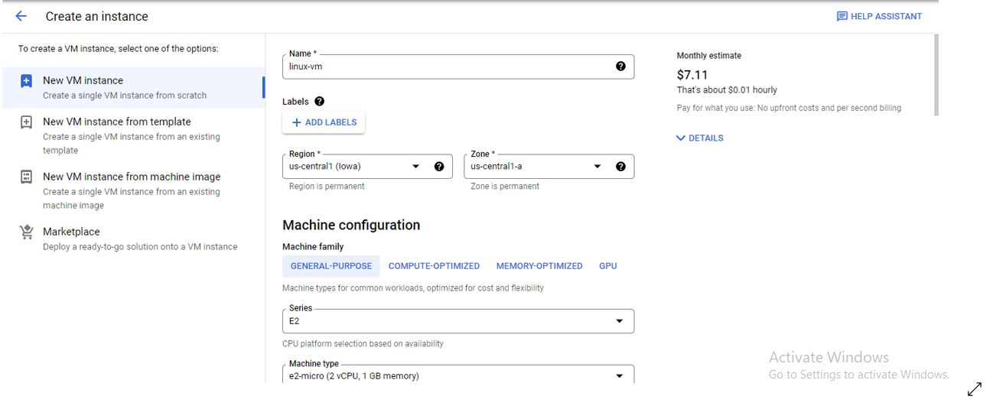

Then to select the linux vm change boot disk type as shown below, 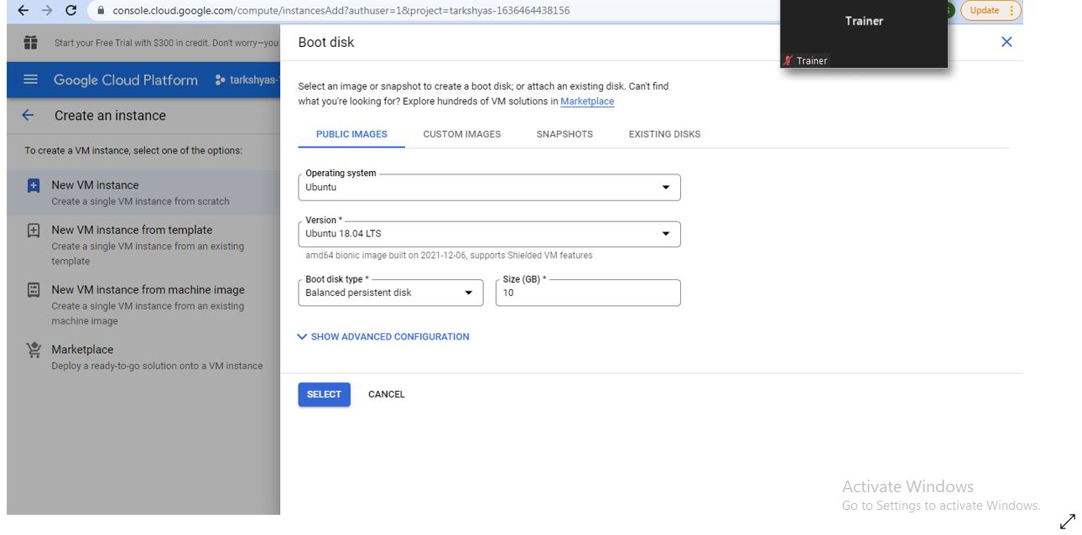

Linux VM instance is created with given name ,

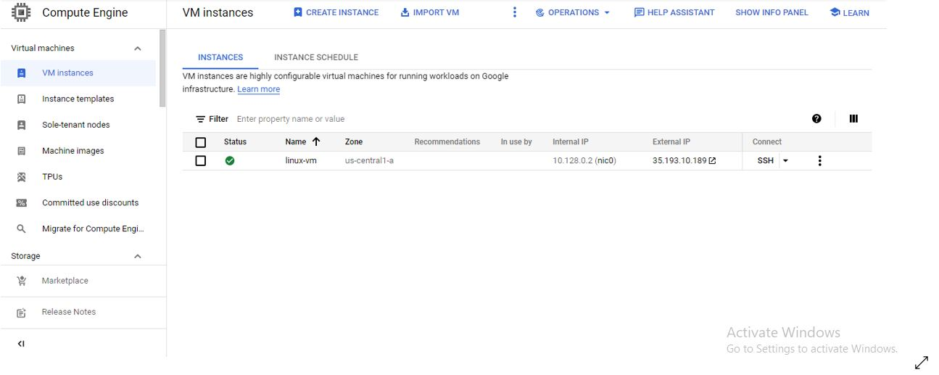

2)Creation of vpc network,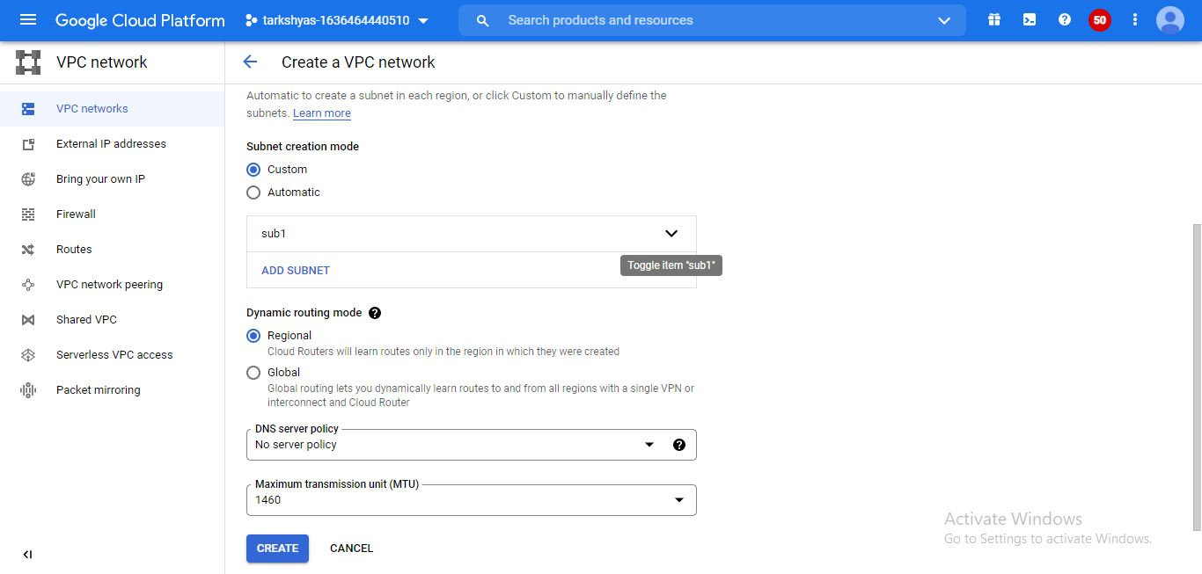

Created a vpc network with asia south region and followed by creating another vpc with another zone as us-central 1 as,

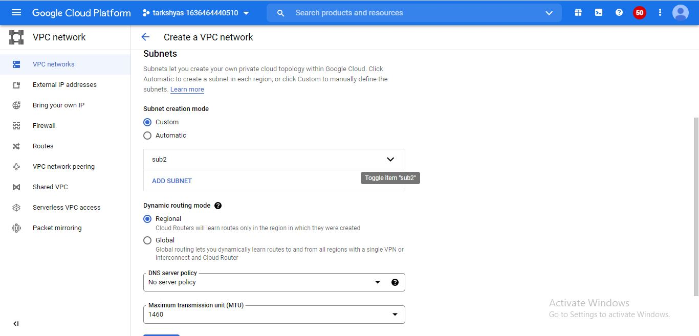

In the firewall riles section, firewall rule is created for both the vpc networks for connecting the VM’s. The 2 firewalls are created as,

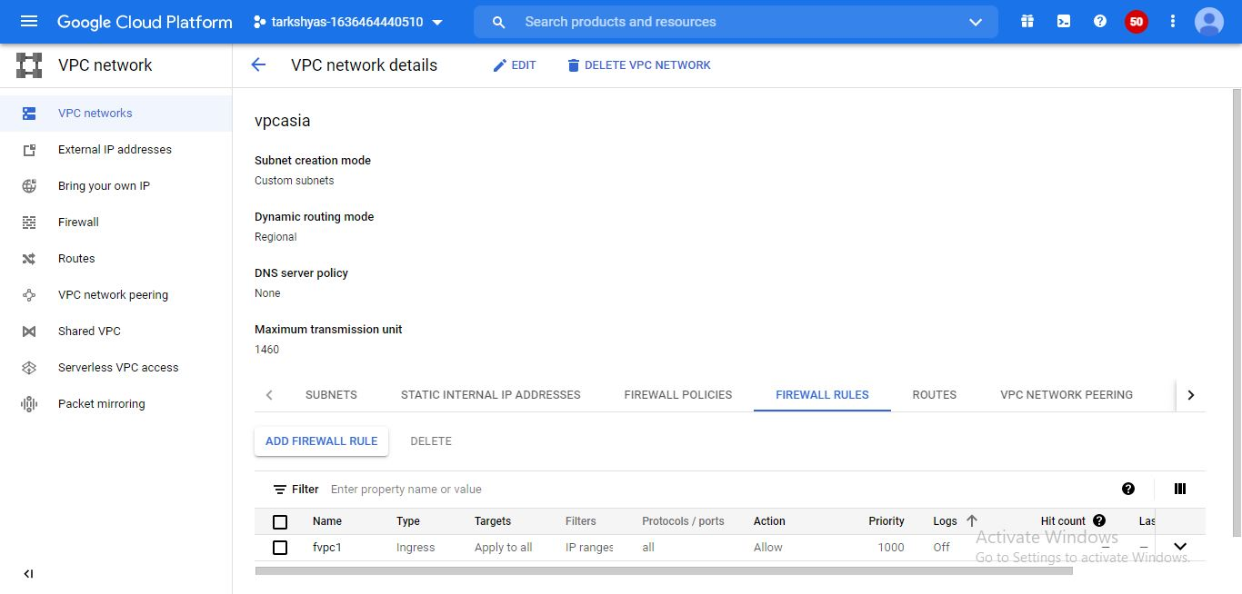

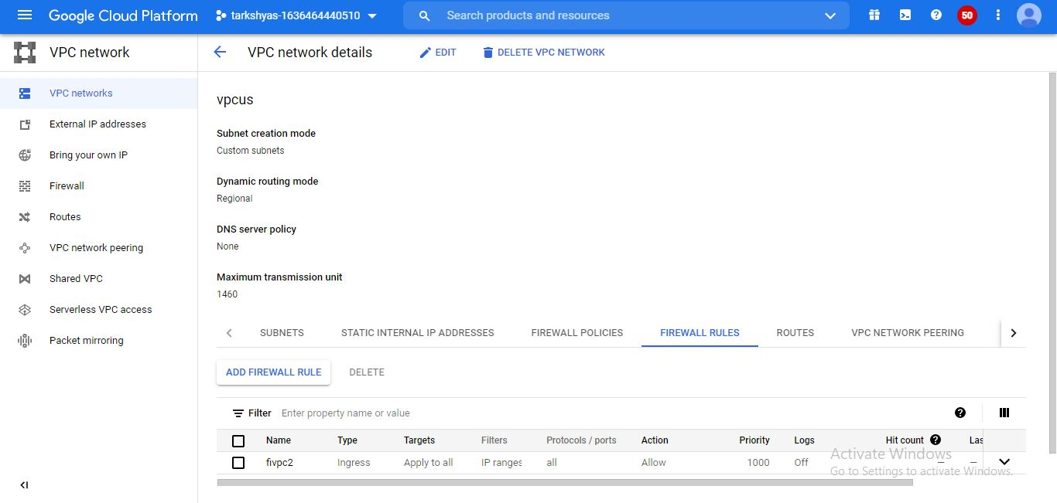

The 2 vm instances are created with different name and zone.Machine configuration and networks are linked to VPC networks.Created VM instances are shown below.

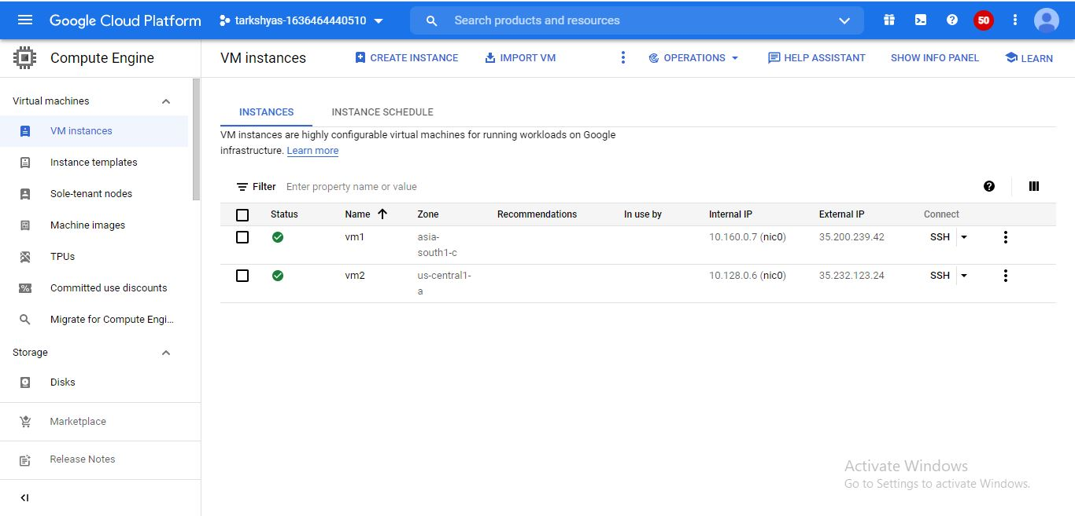

For each VM instances static IP addresses were reserved. For creating gateway,VPN were created for each instances as shown below,

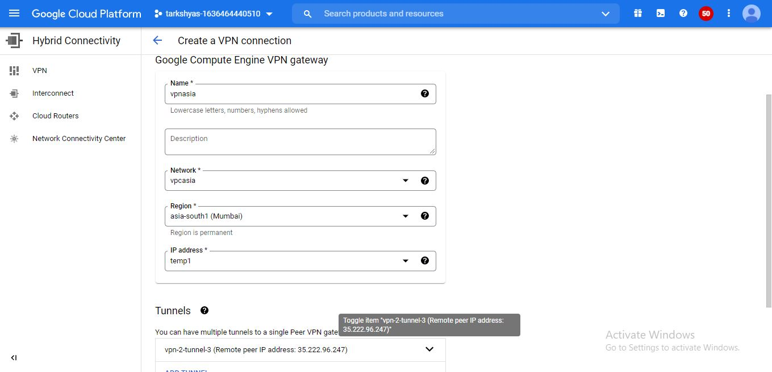

The subnet IP address added to each VPN and tunnels were created for connecting two Instances as shown below.The remote peering ip given and route based connection is used.

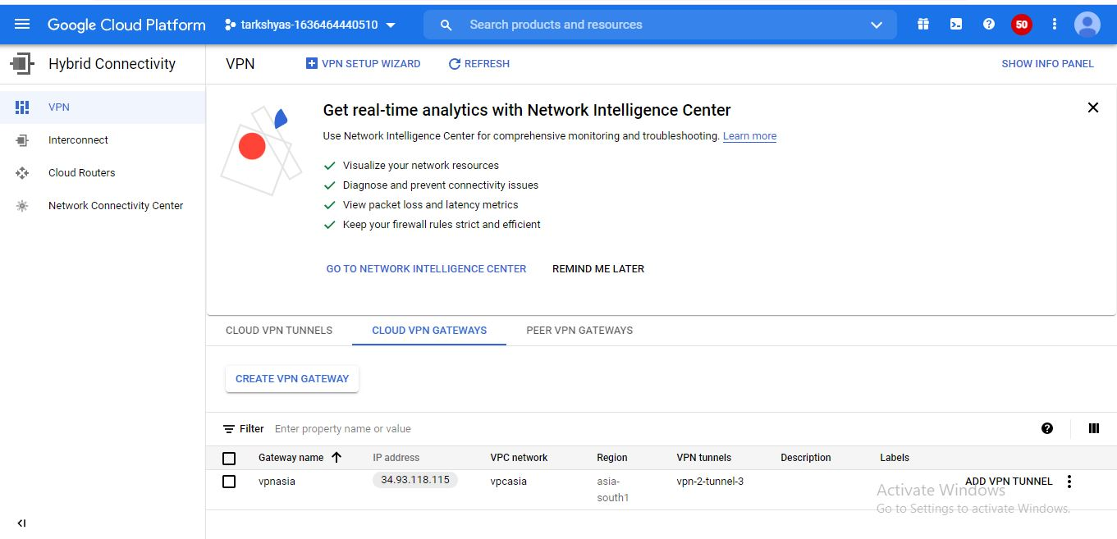

Figure shows the 2 VPN connections.

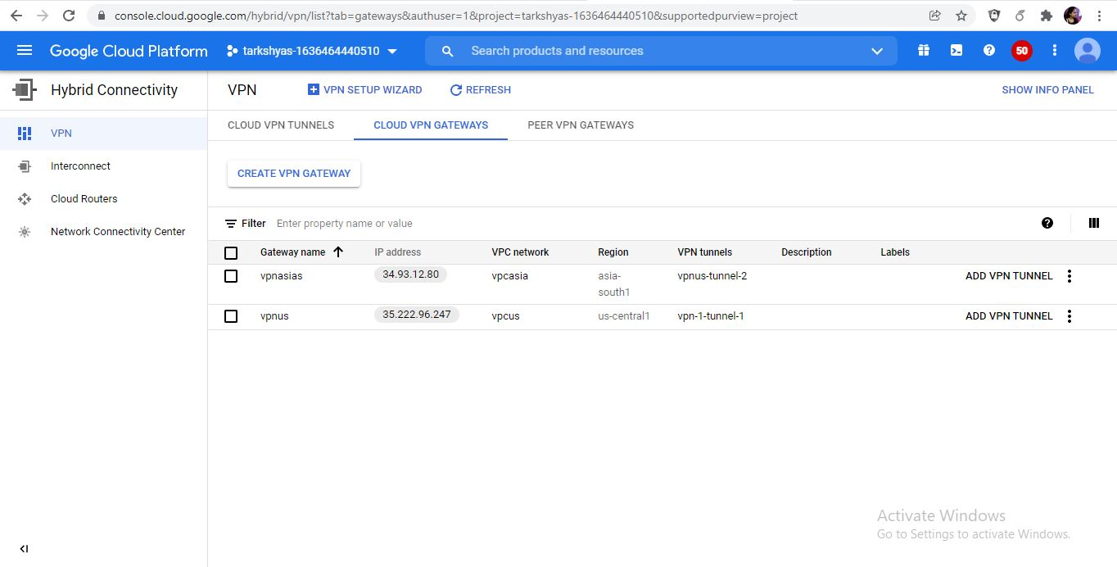

To connect the 2 VM instances the two instances were pinged as shown in figure.

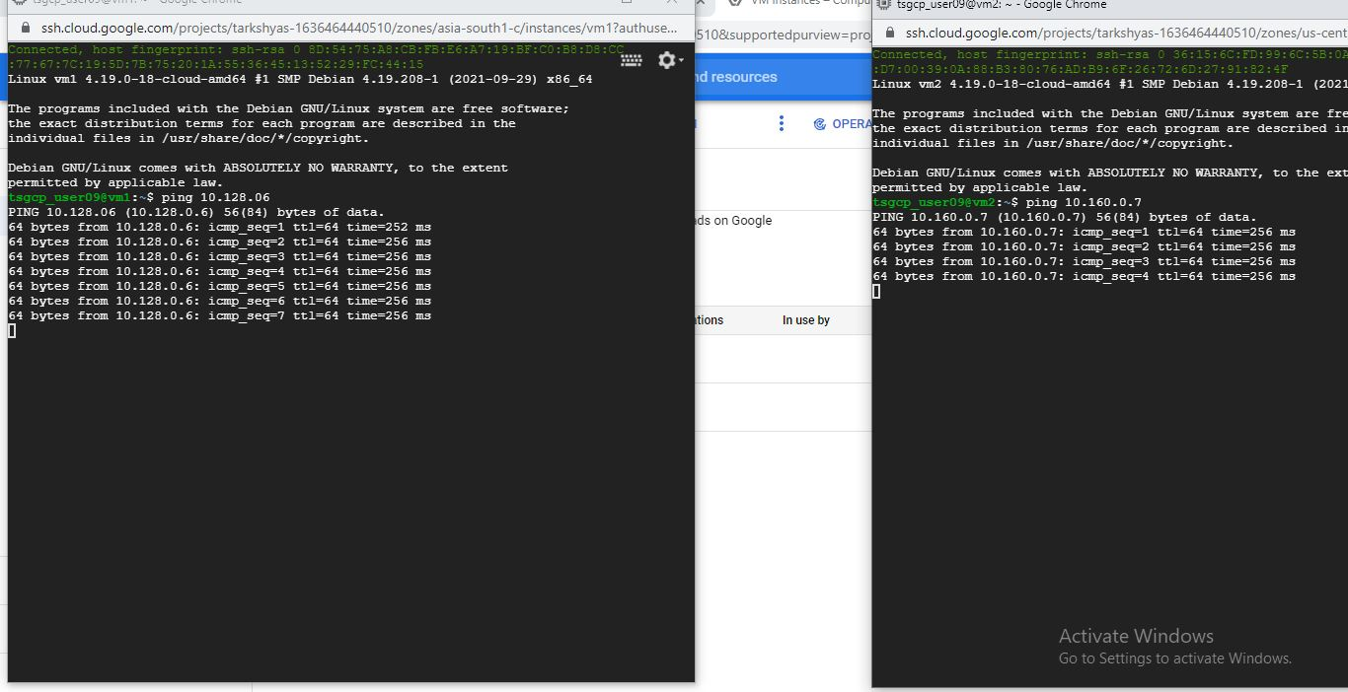

3)App engine standard

App engine is used for developing and hosting web application at scale.In the standard environment the application run on lightweight instances.

First we have to clone the github account as below,

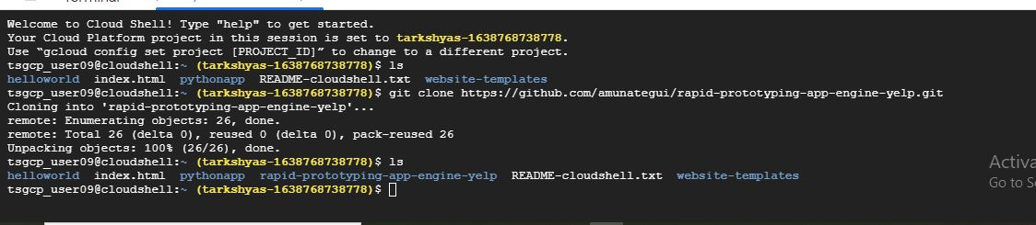

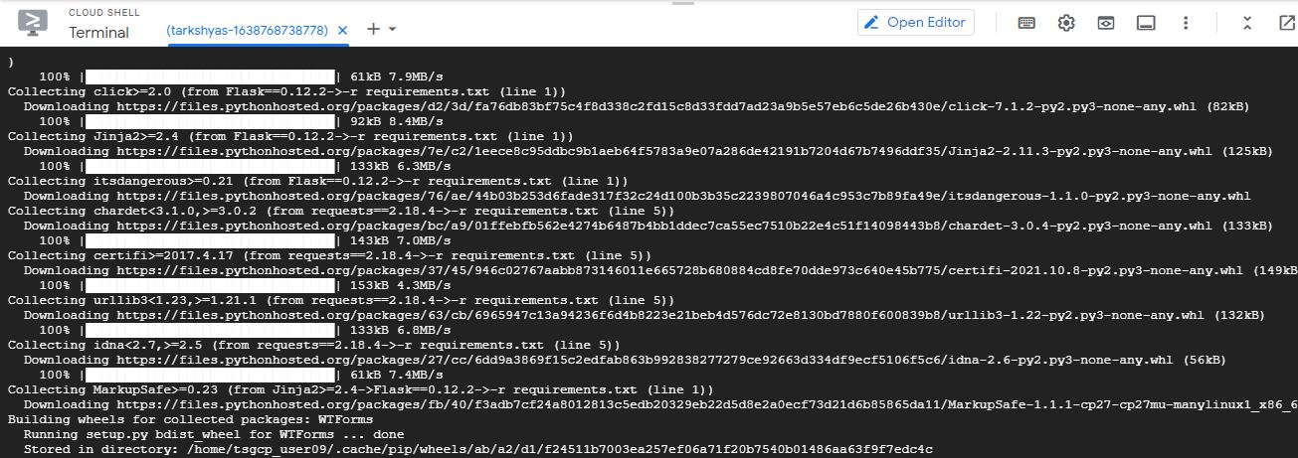

Follows the steps as,

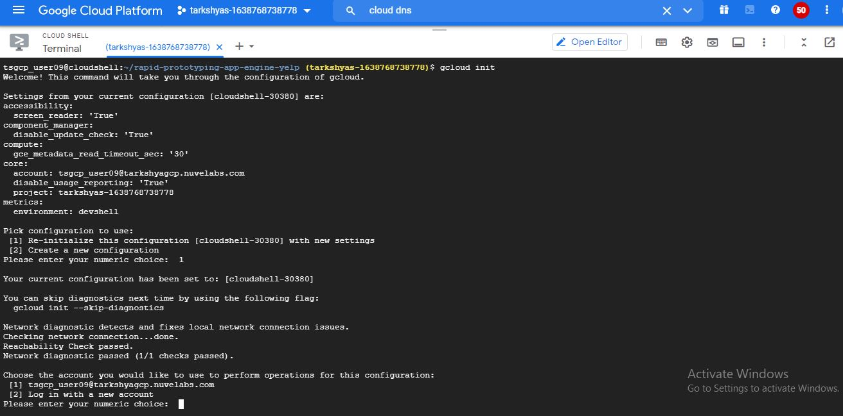

Deploy the gcloud app into app engine.

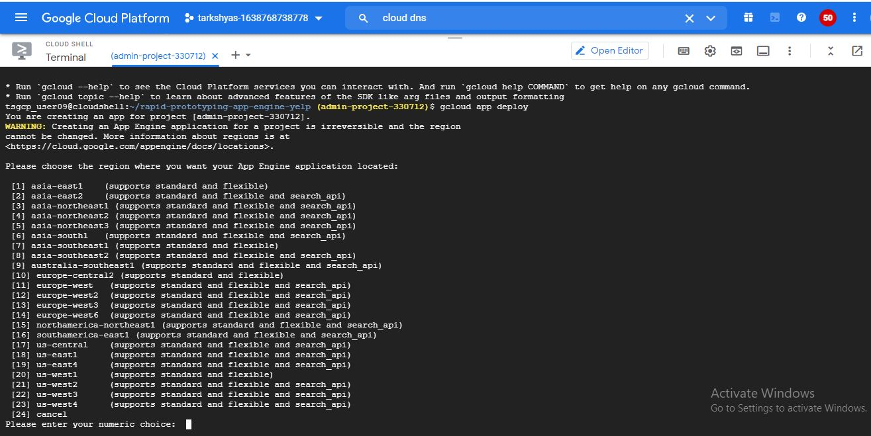

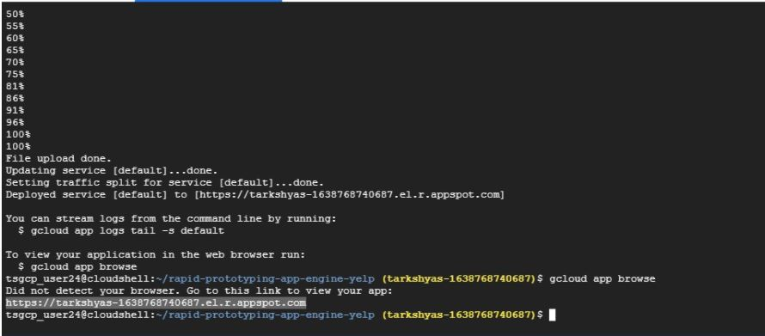

We got a link after deploying and browsing the gcloud app and finally got like this.

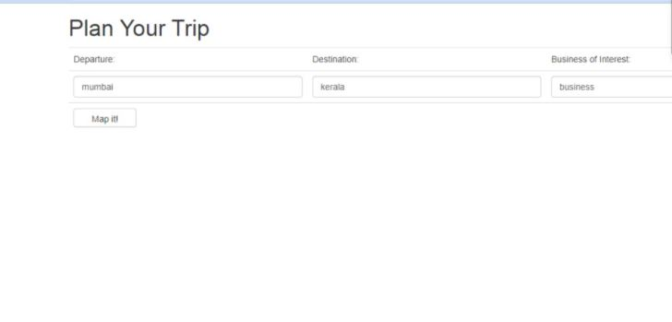

4)App engine flexible

In flexible environment,application runs in docker containers and it can be scalable.There are different types of scaling like automatic scaling,manual scaling etc.













5)Google cloud function is a serverless execution environment for building and connecting cloud services.Create a cloud function with name and region as,

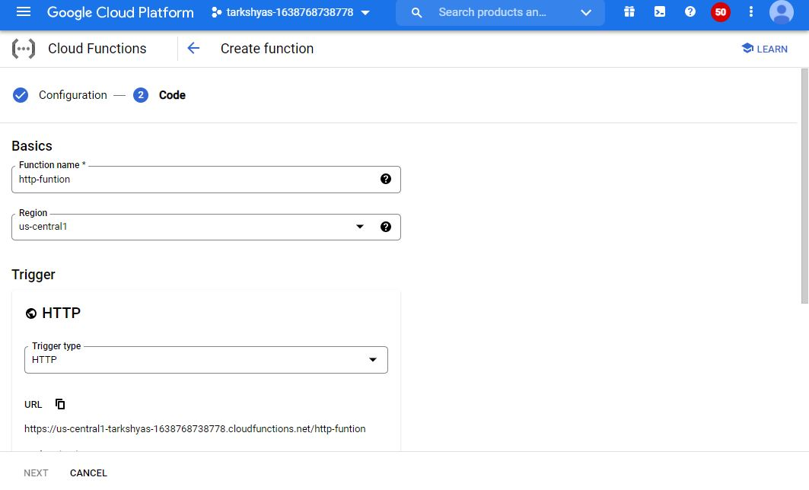

Follow the steps 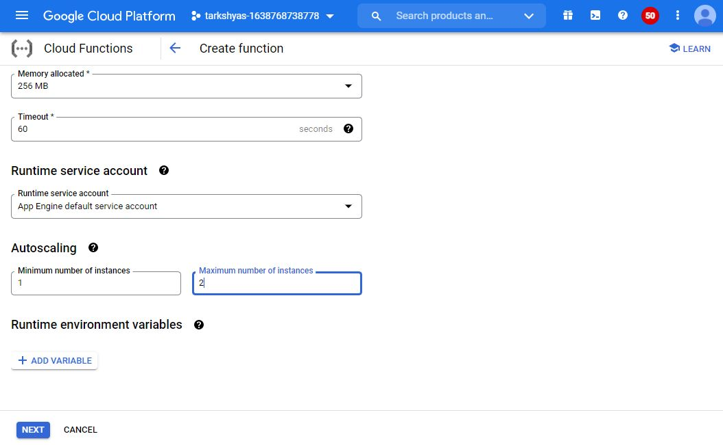

The cloud function is created,

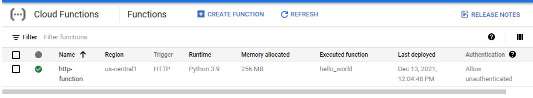

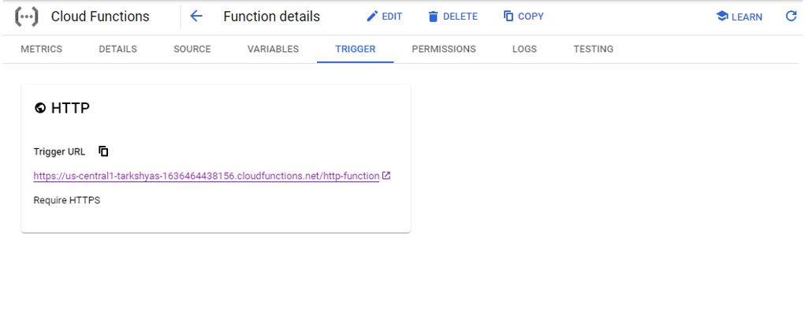

When click on the link it will show like the below figure.

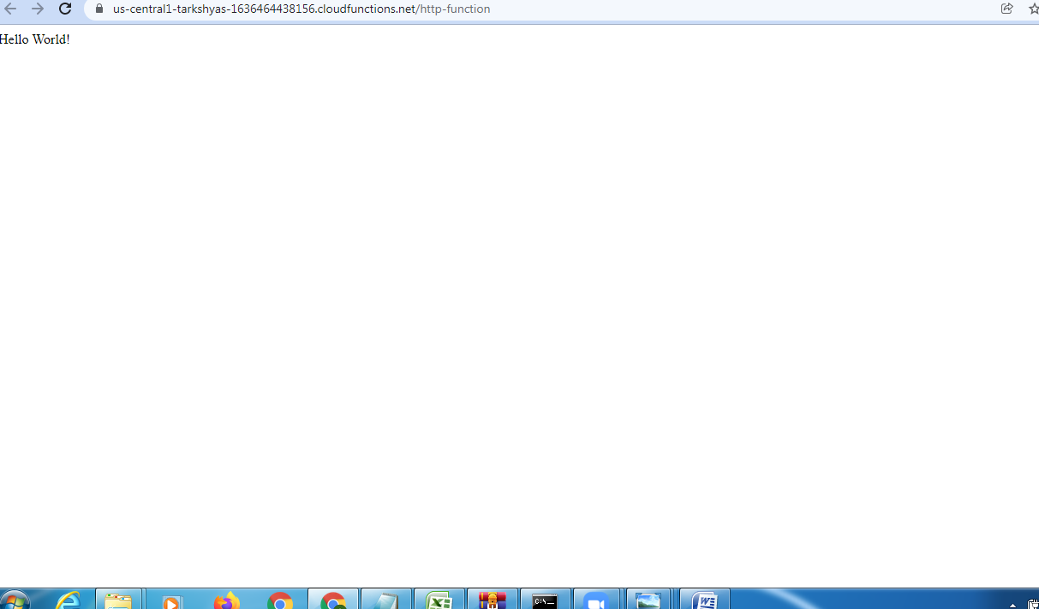

6)Cloud run is a managed compute platform that enables to run containers that are invocable via requests or events.

The commands for building, tagging and pushing to a container registry as,

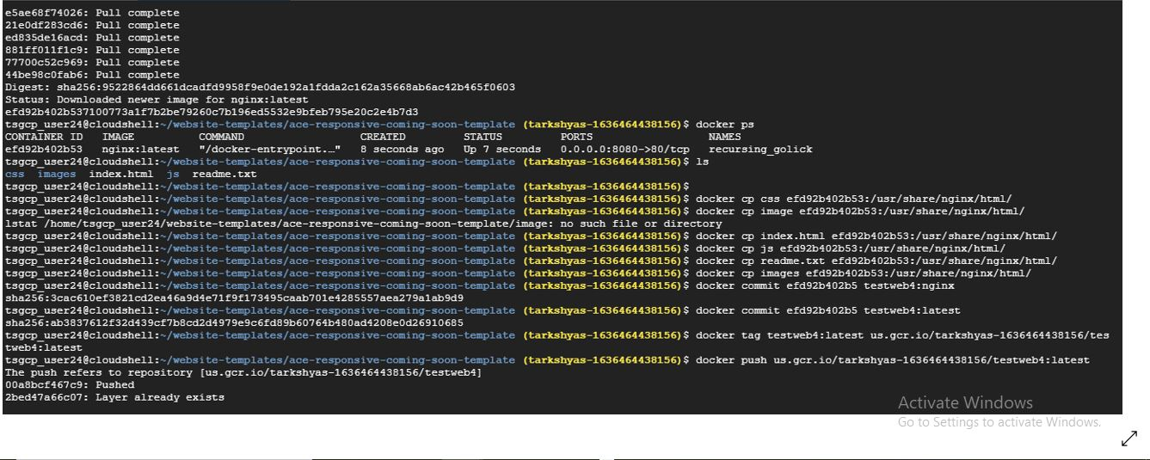

Go to cloud run and create a service with selected container registry as,

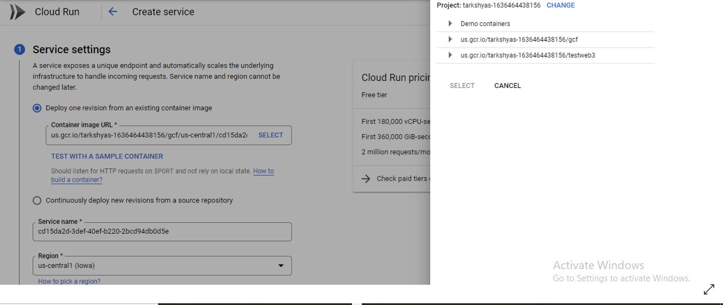

Select the minimum and maximum number of instances,

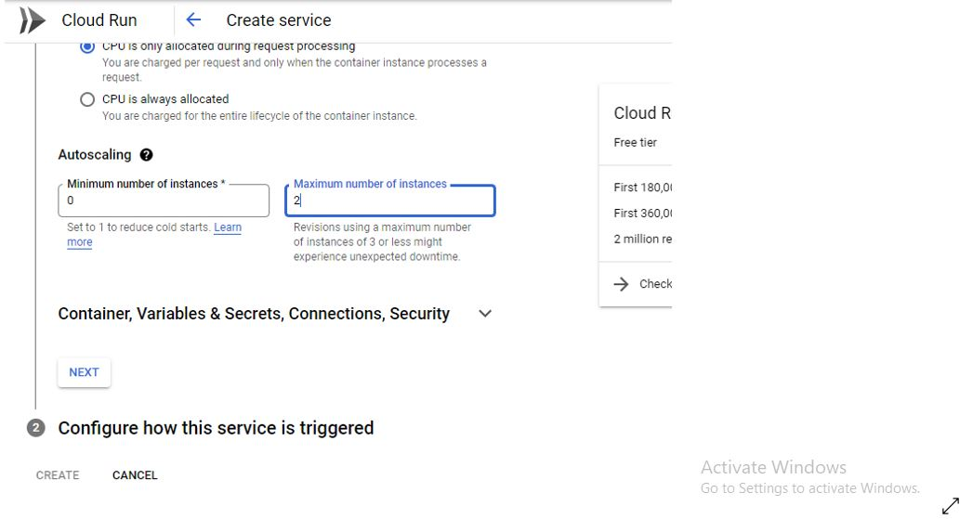

Configure the service triggering,

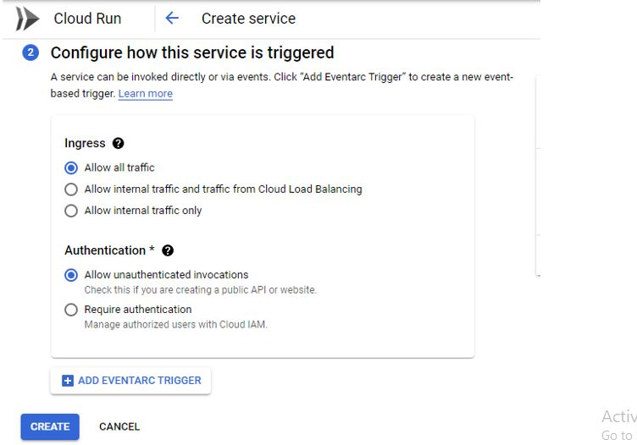

Then the services were created as below

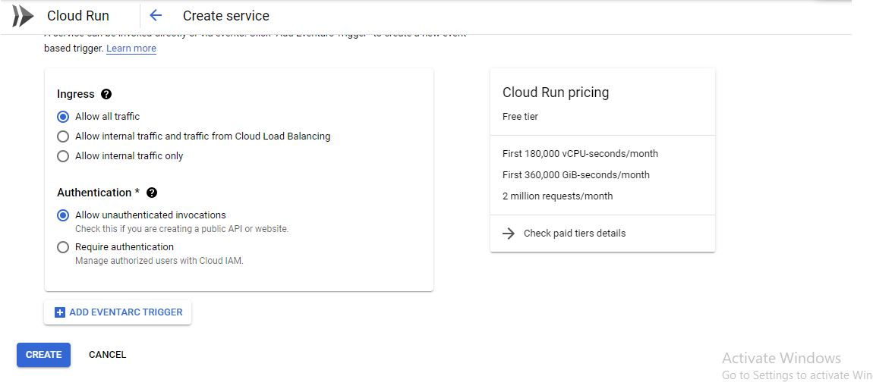

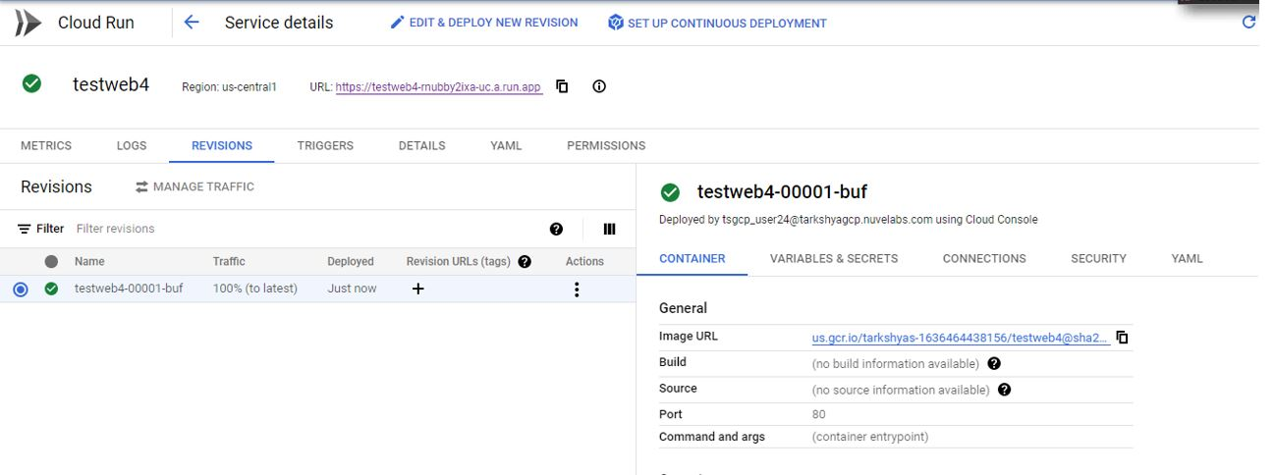

Can see the created app.

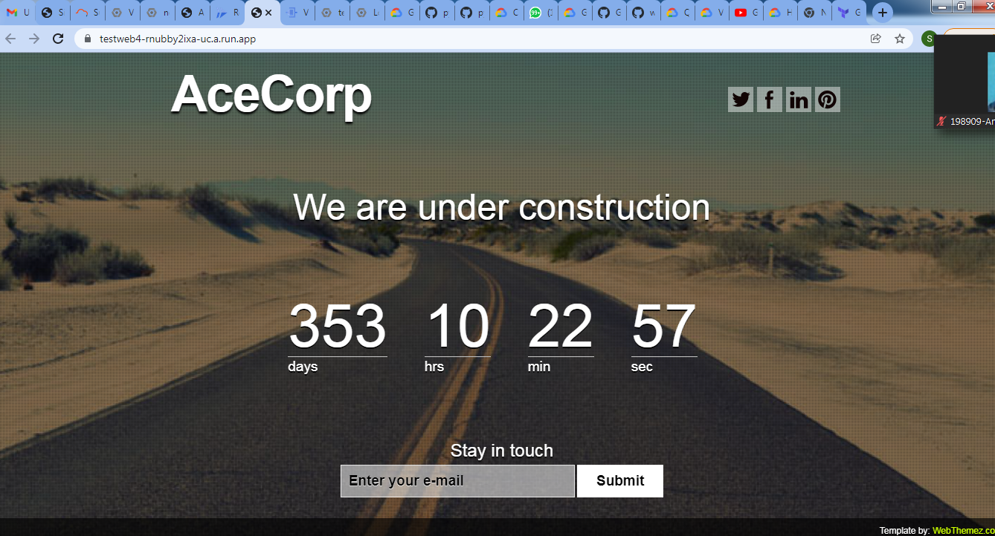

7)Peering allows internal IP address connectivity across two VPC’s.First step of peering is the creation of VPC as shown in figure.

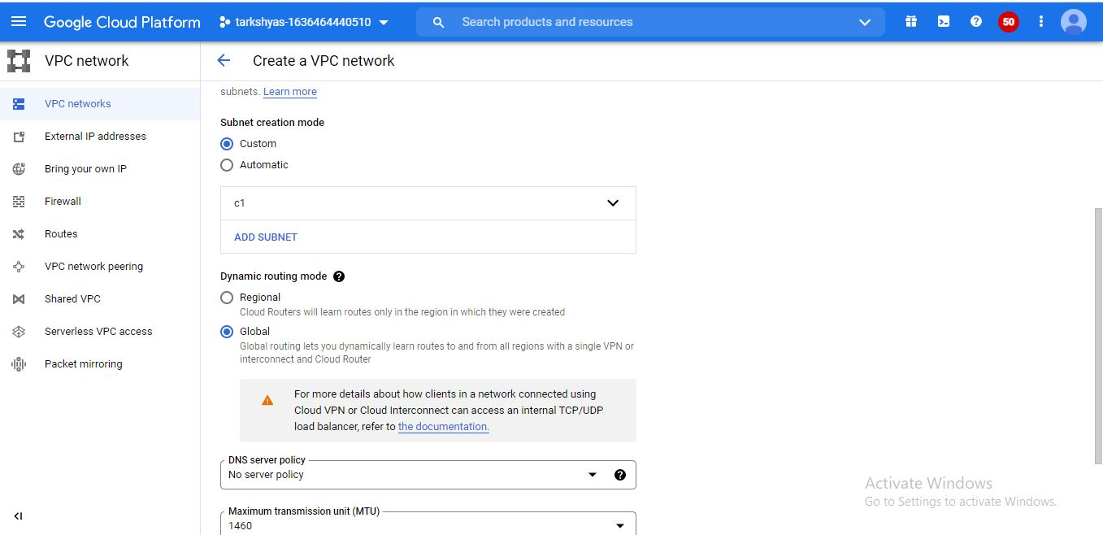

To peer the network,teo VM instances were created with different zone,and anyone should have the same zone of created VPC network for peering.VM instances created as shown below,

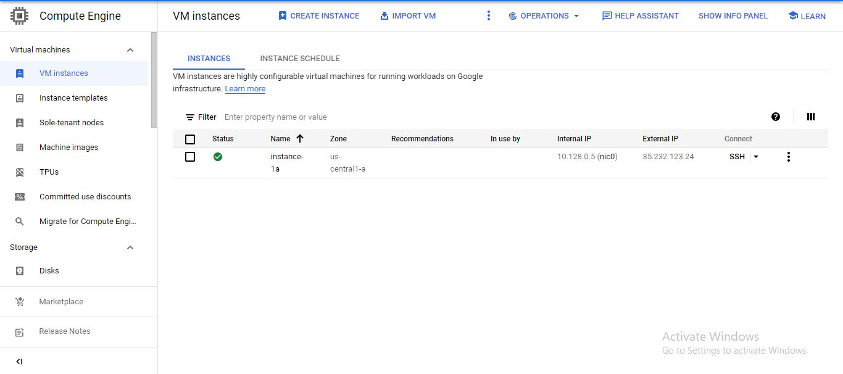

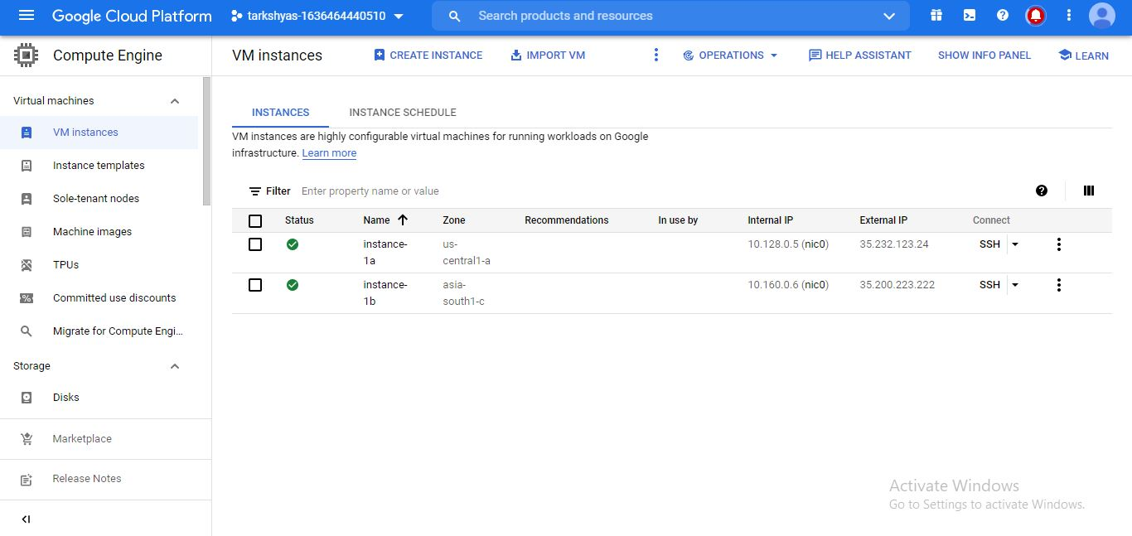

VPC peering connection is created as shown below,

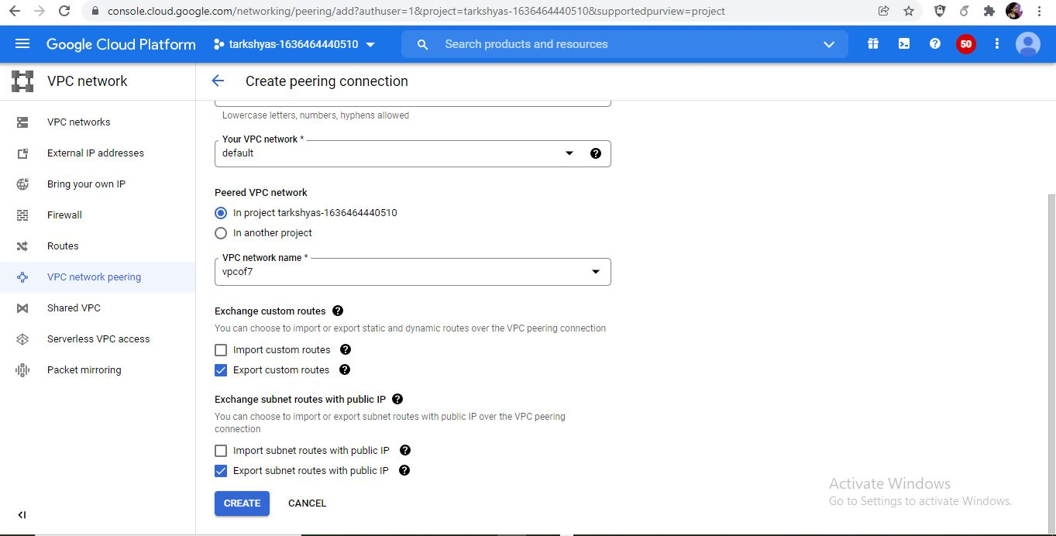

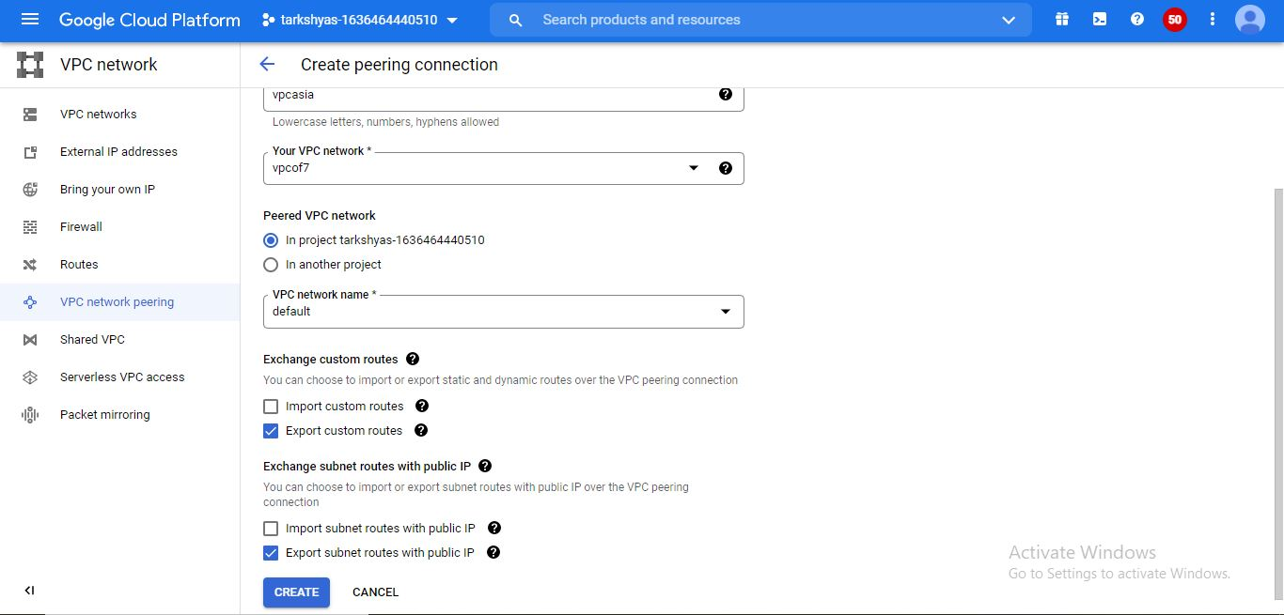Finally peering is done with 2 connections as,

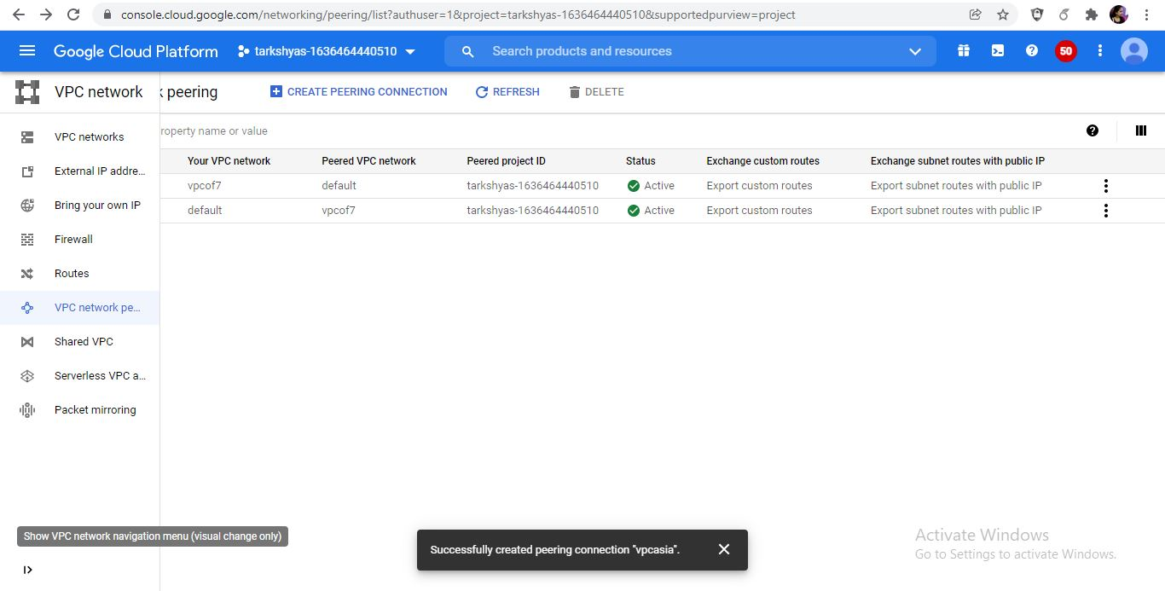

8)Cloud DNS

Google cloud DNS is a high-performance,resilient,global domain system service.It helps to gives the organization a way to push DNS zones and recordes easily either for external users or internal users without requiring an IT team to manage the servers and software it takes to do that.

First want to create a VM instance to host the DNS.

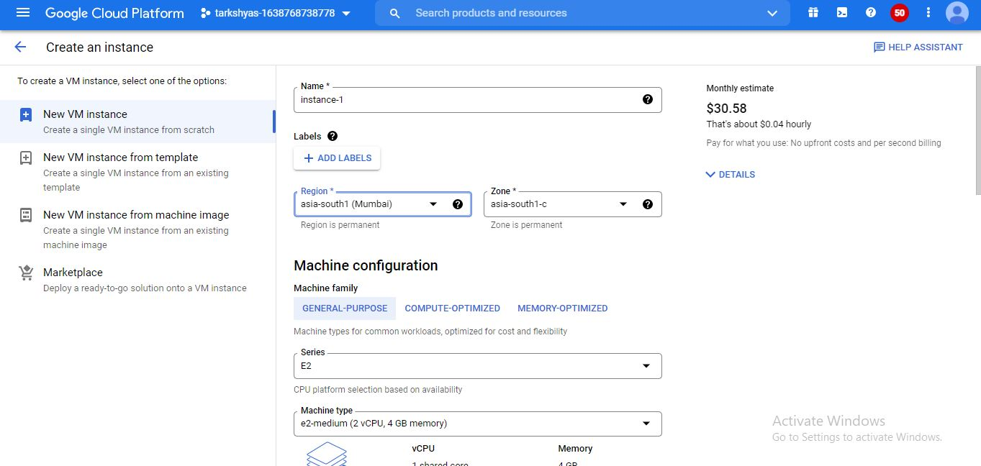

Reserve a static ip address with the specified region.

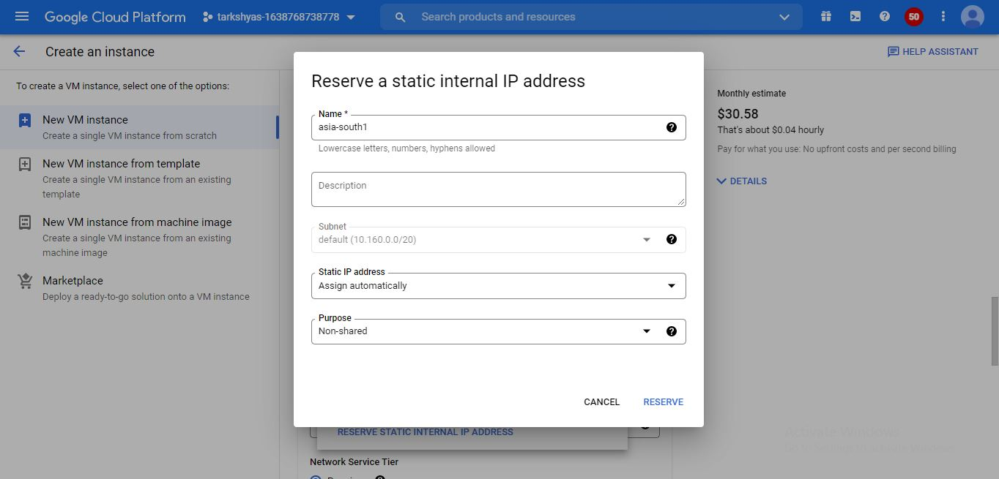

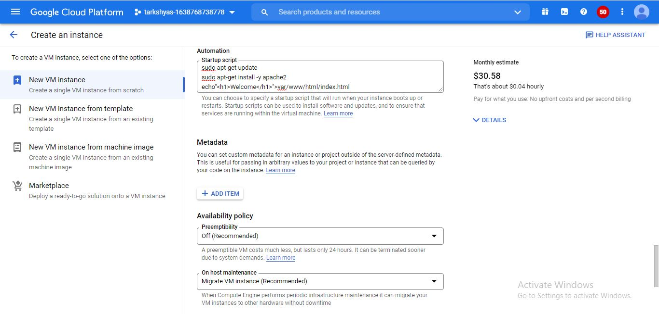

By scripting and VM instance is created as,

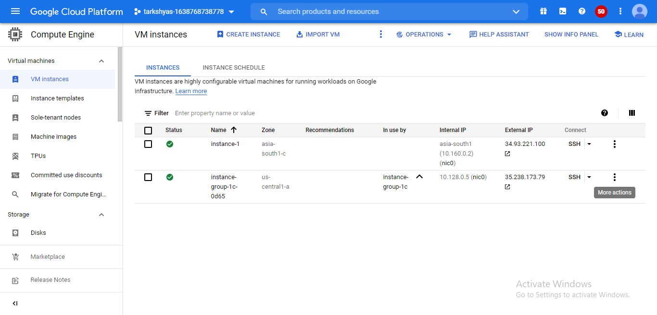

After creating the VM instance enable cloud DNS for accessing the host.

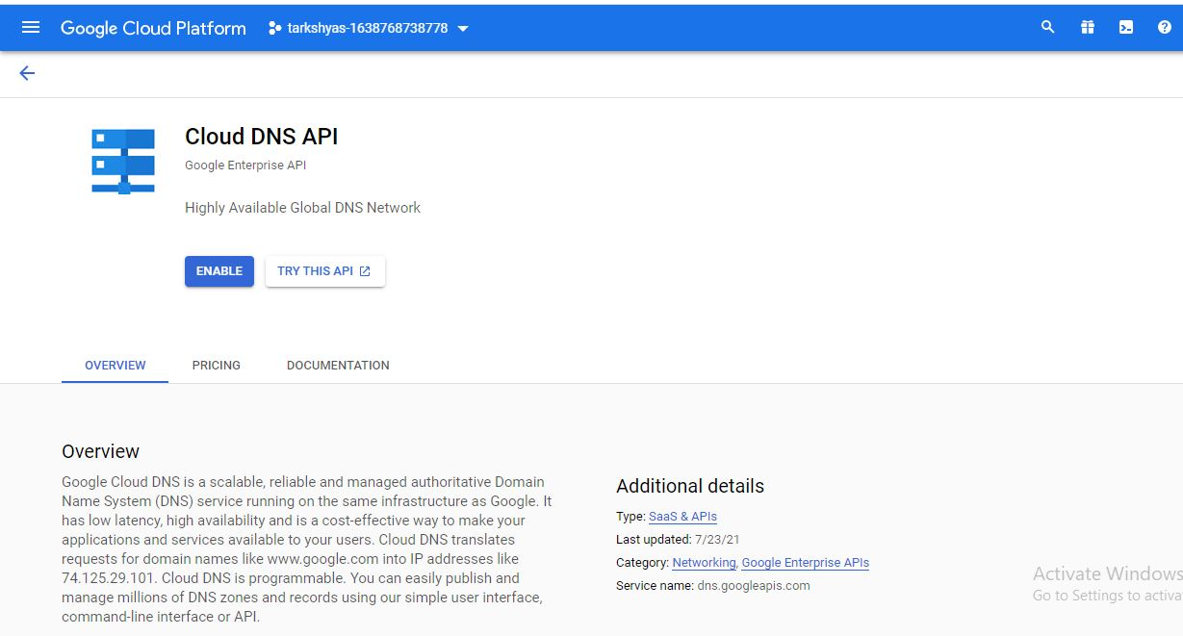

Then create a DNS zone,

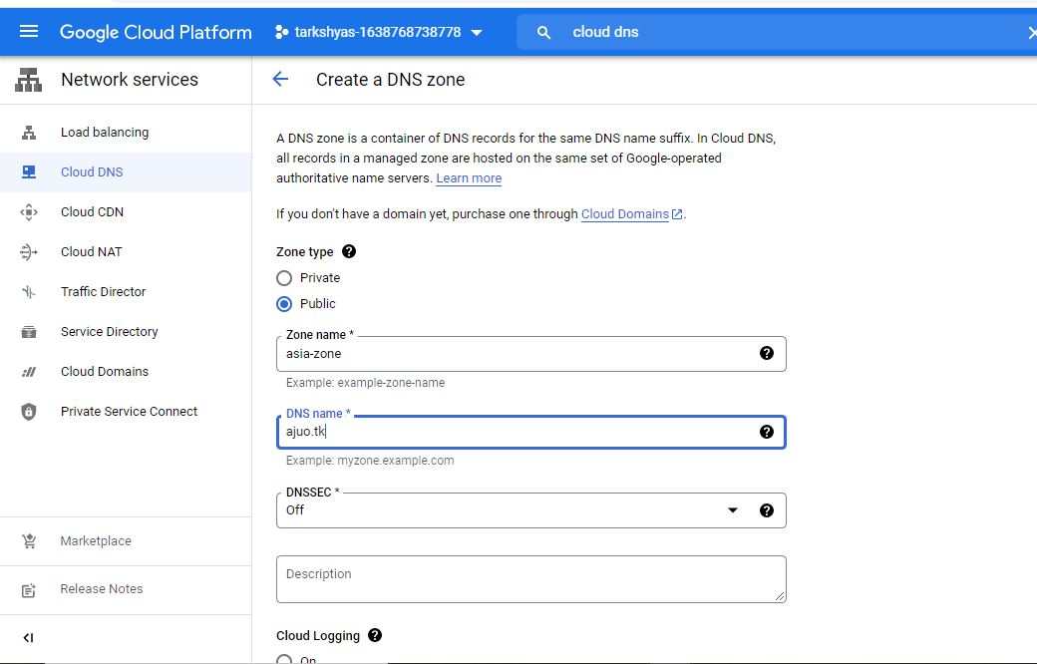

The zone is created.

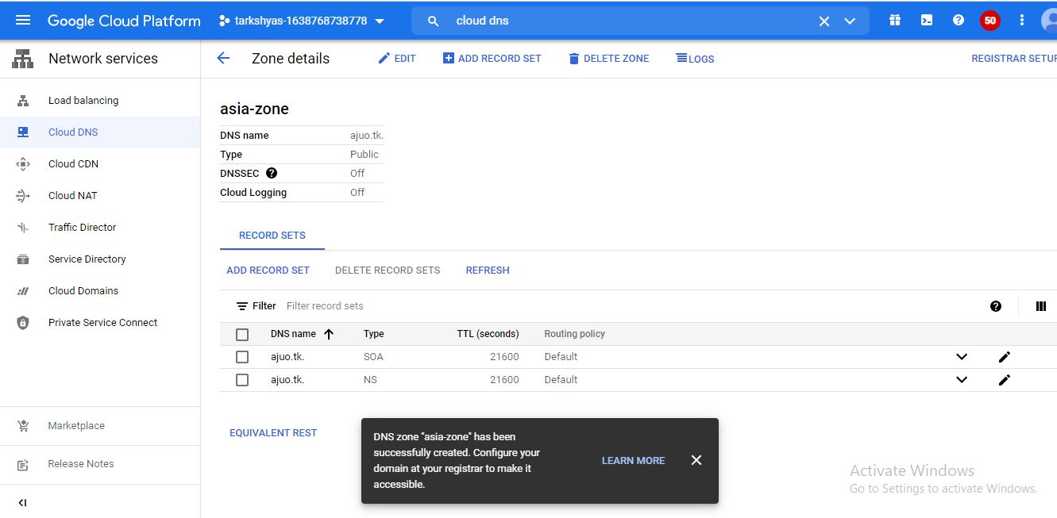

Freenom is a free domain service application.By logging into the registered account we can access a domain with different domain.then get nameservices with customers choice.

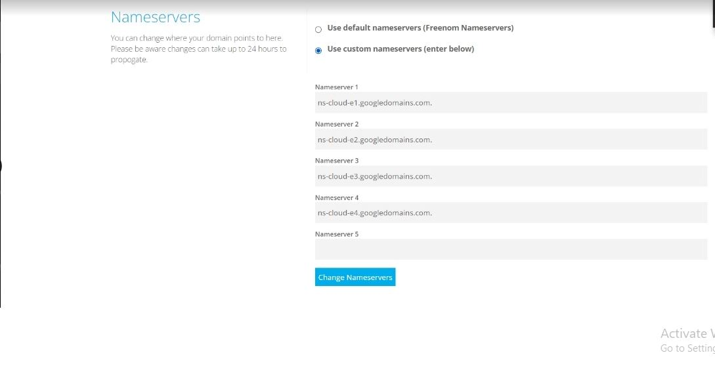

Open the site that we already given in cloud DNS and obtained like the following image.

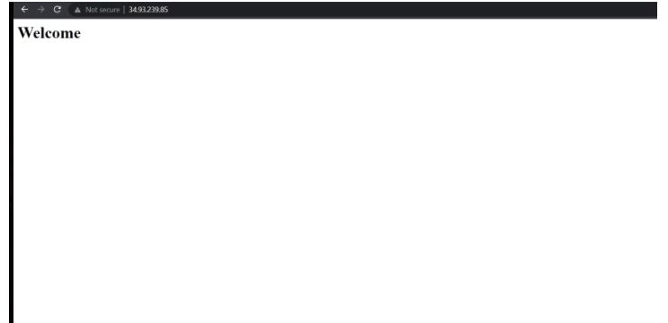

9)The google cloud load balancer is the software defined globally distributed load balancing service.The first dtep is to create an instance template as,

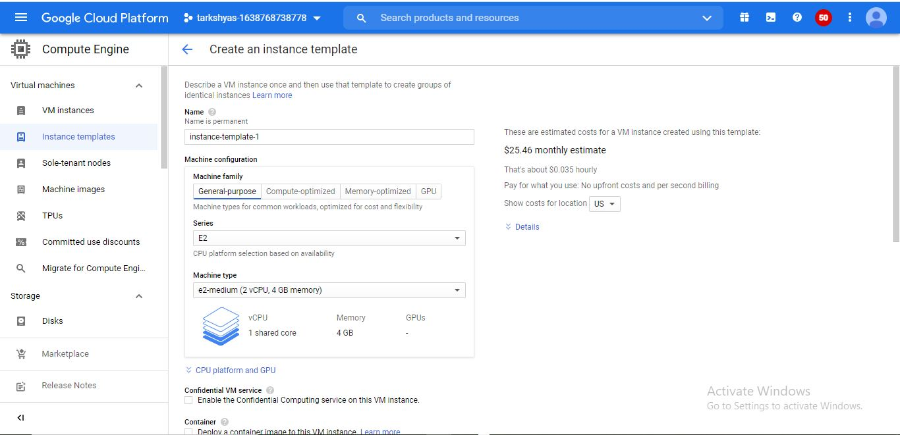

This is used for http load balancing.

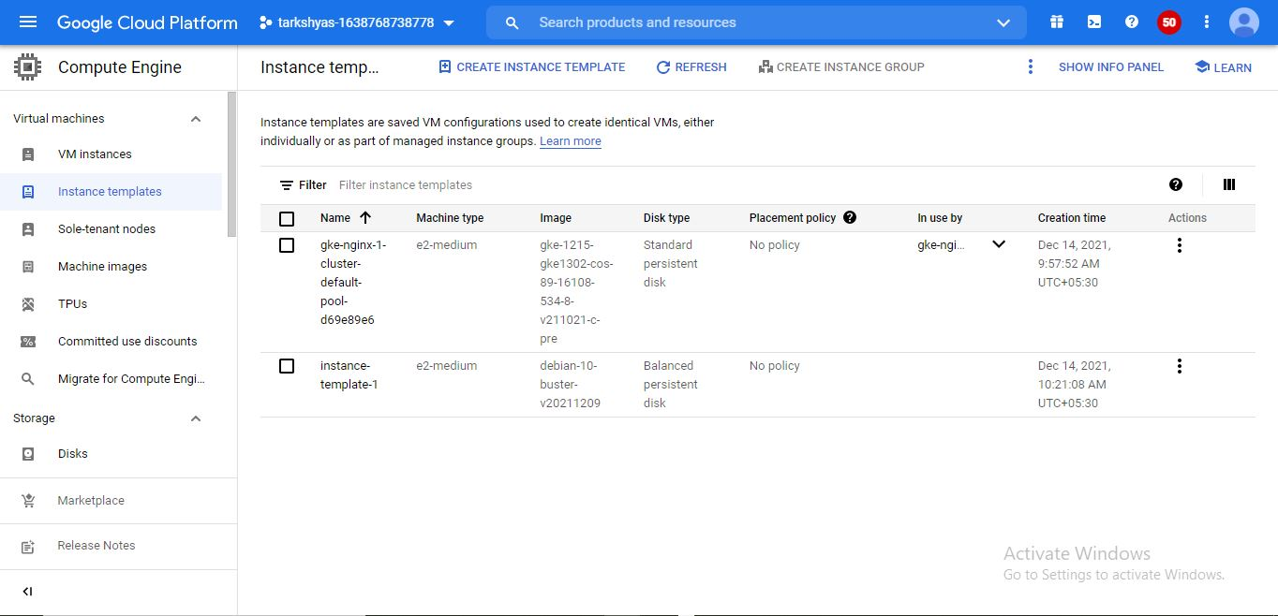

It is followed by creating the instance group as shown below,

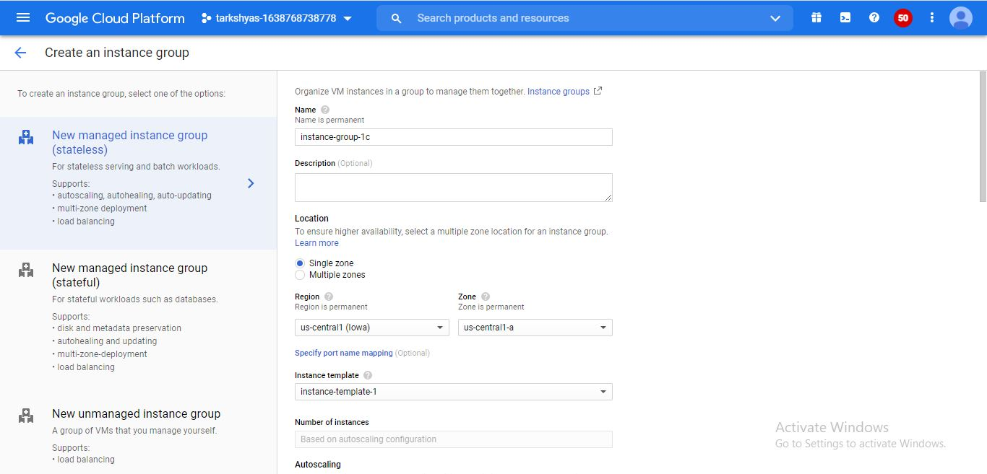

Followed by the steps as,

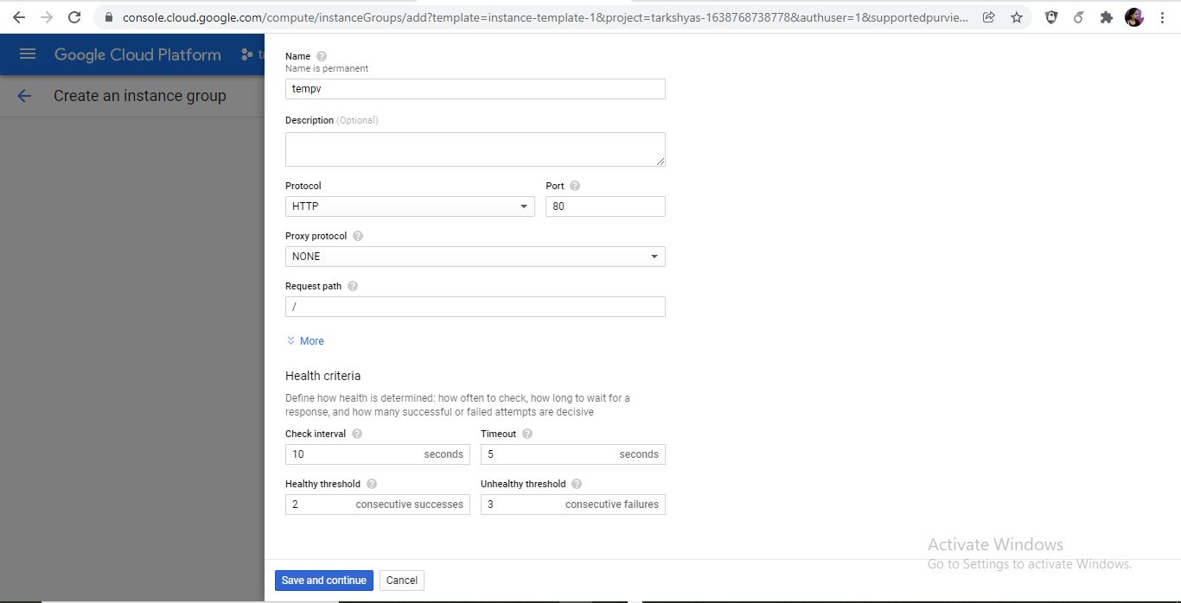

Provide health check and auto healing like,

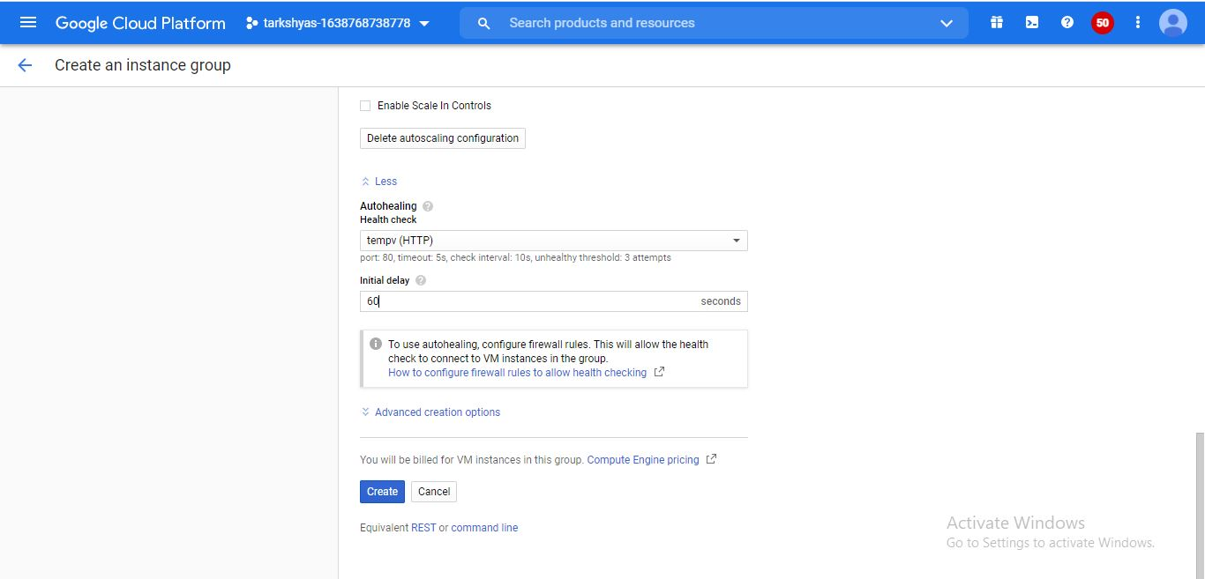

The instance group is created with the given name.

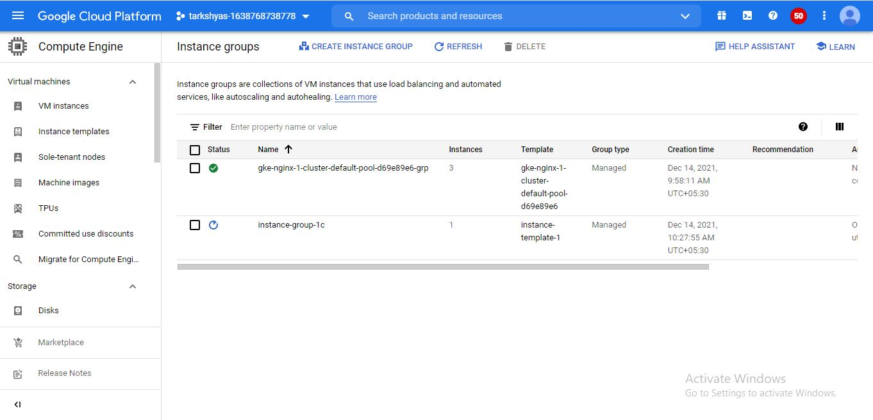

Then create load balancing in the network service for HTTP load balancing as,

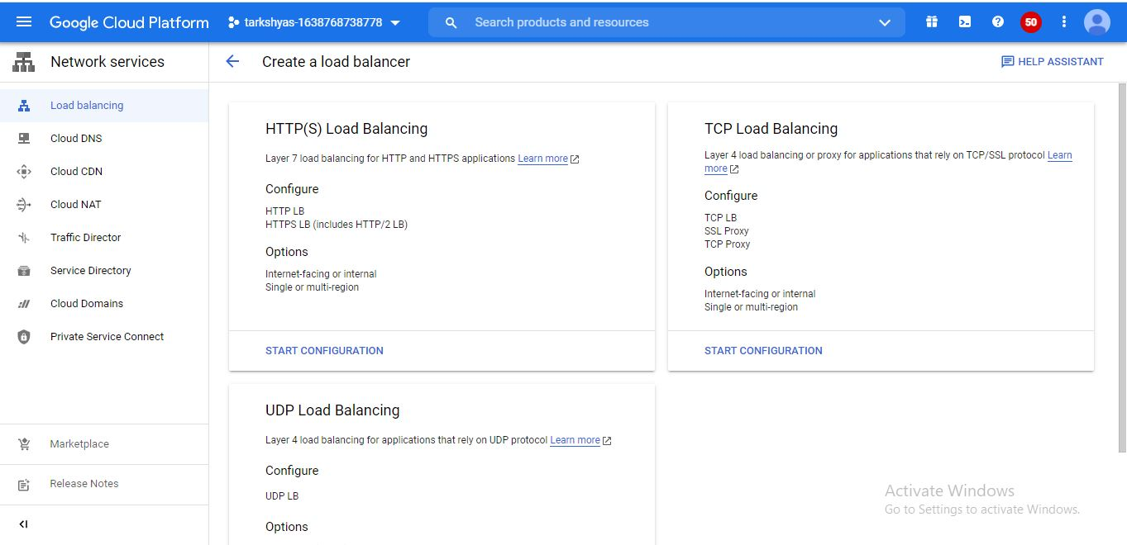

Create backend for load balancing like,

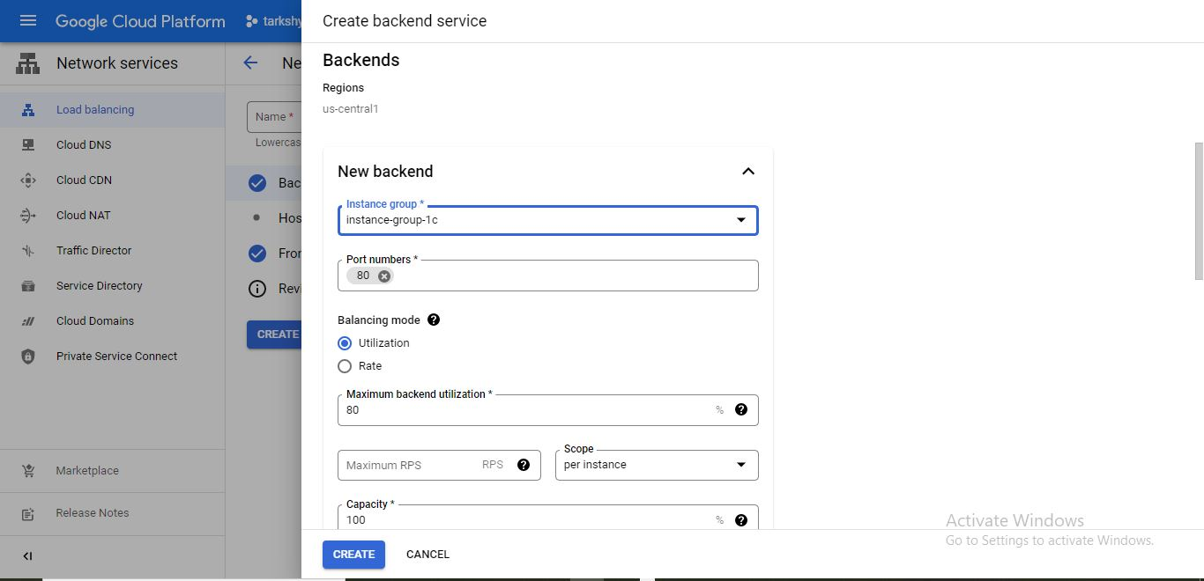

Create backend and front end as shown below,

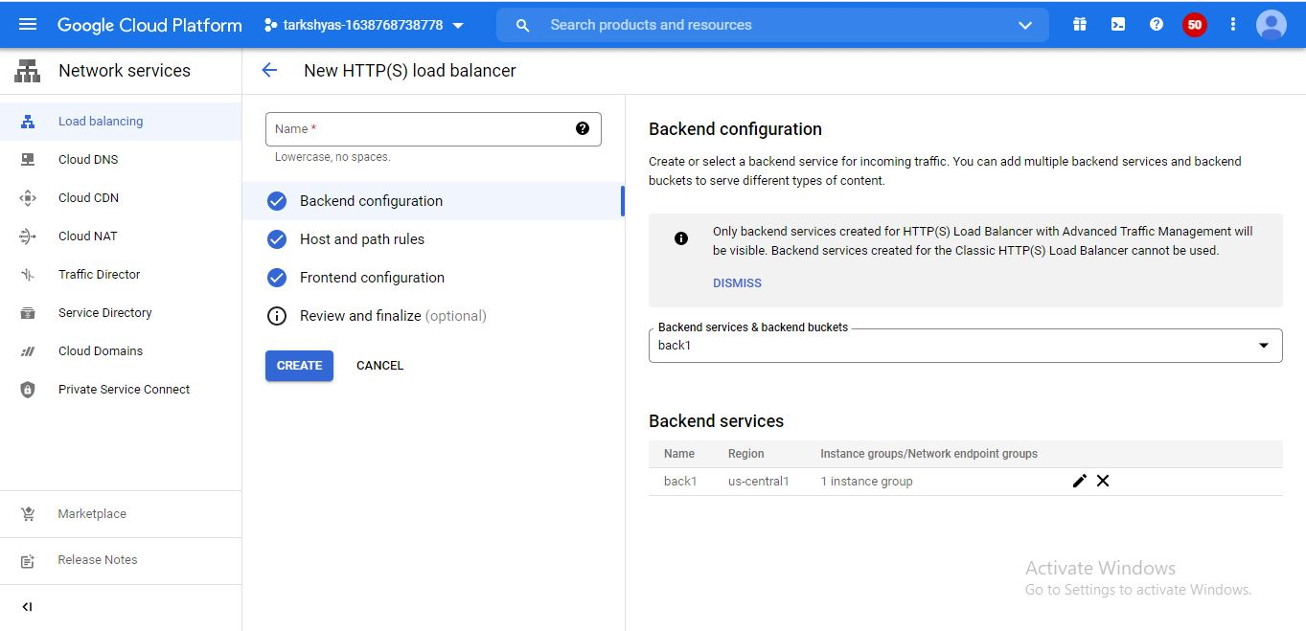

And created the load balancer for HTTP,

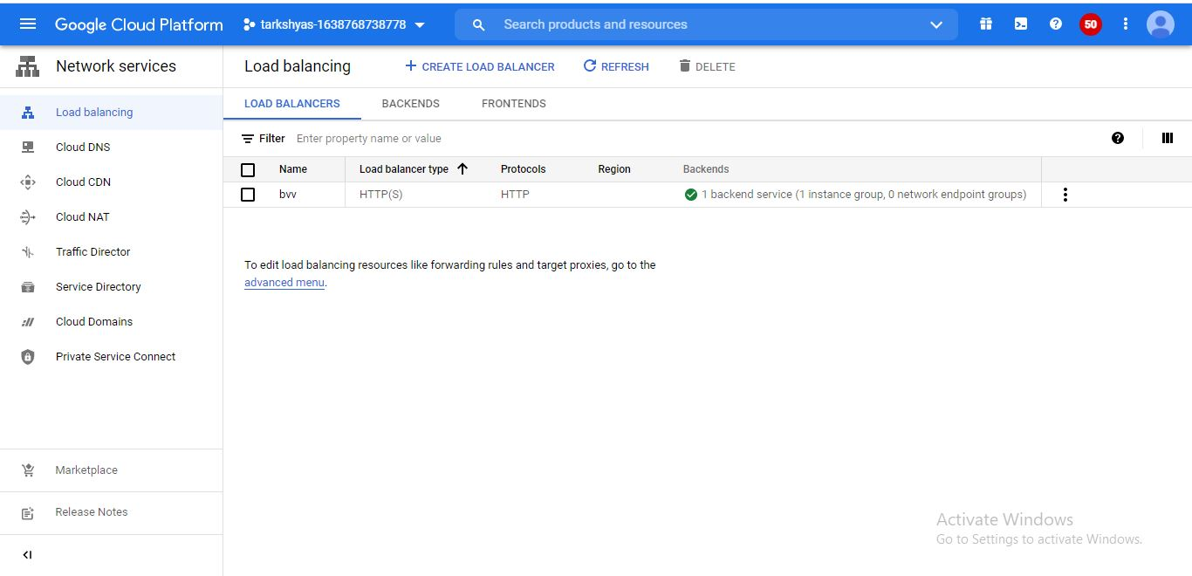

Load balacer for TCP follows the steps,

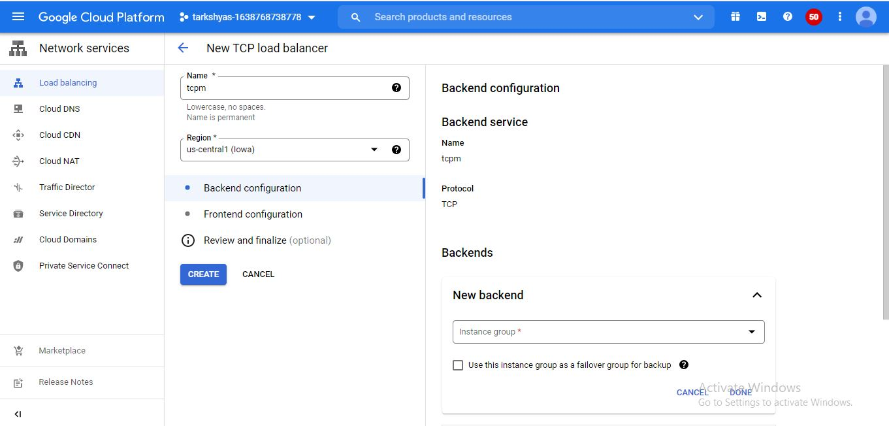

Create backend and give name for the tcp load balancer,and give health check,

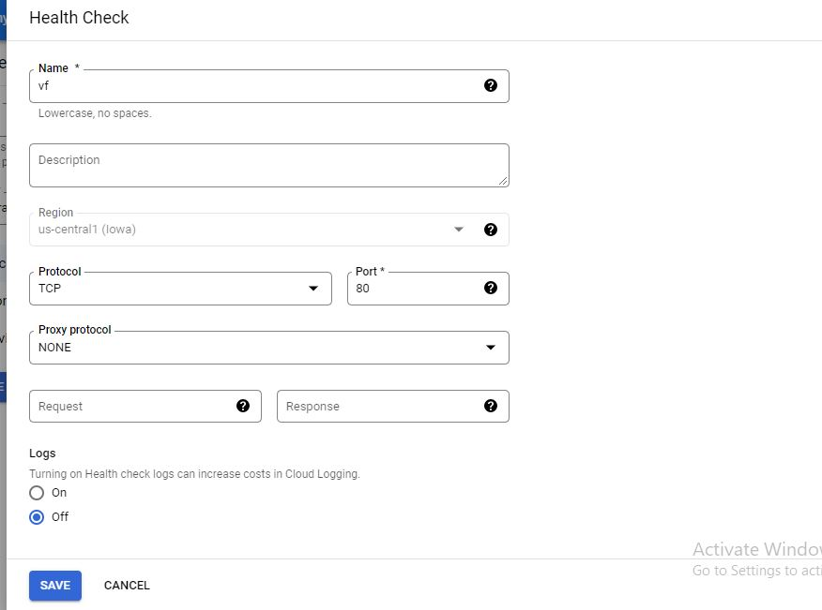

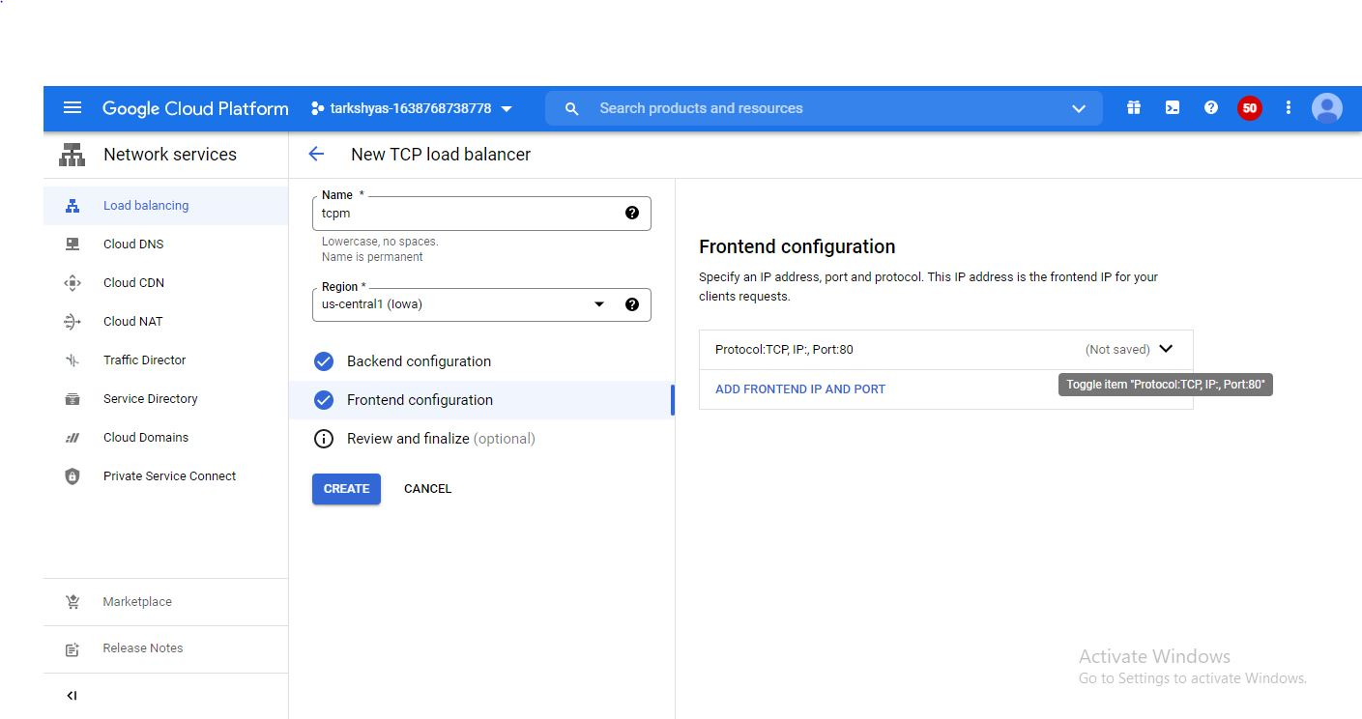

Finally the load balancer is created for tcp as shown below.

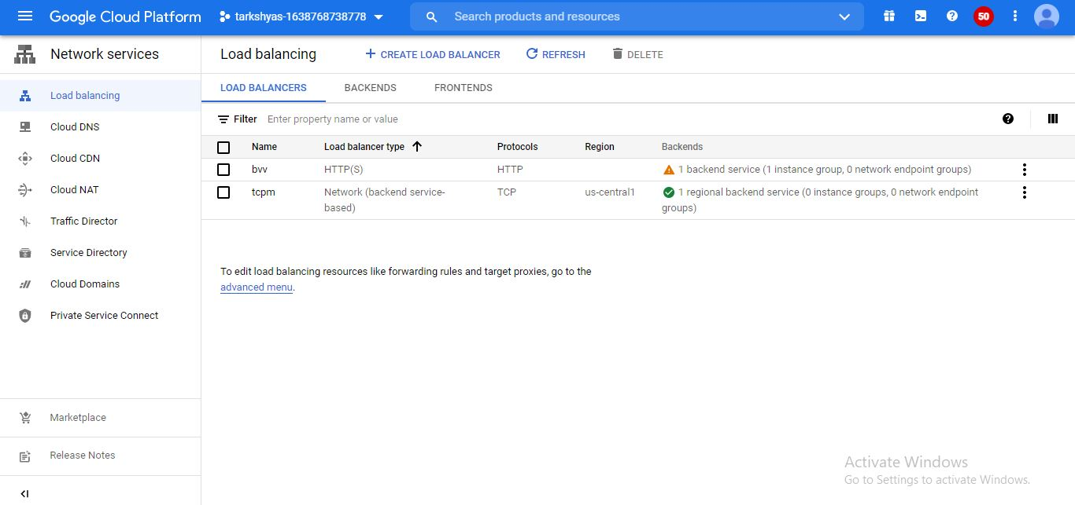

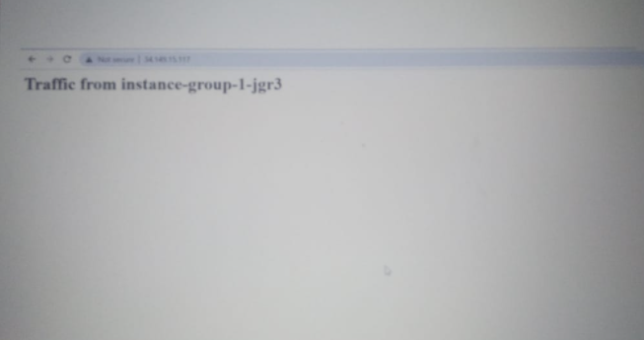

10)GKE provides a managed environment for deploying, and scaling the containerized application.

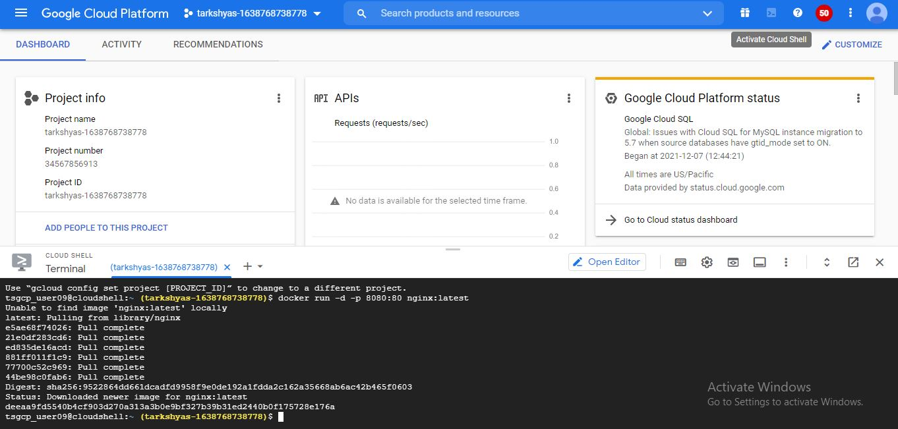

Activate cloud shell and follow the stpes,

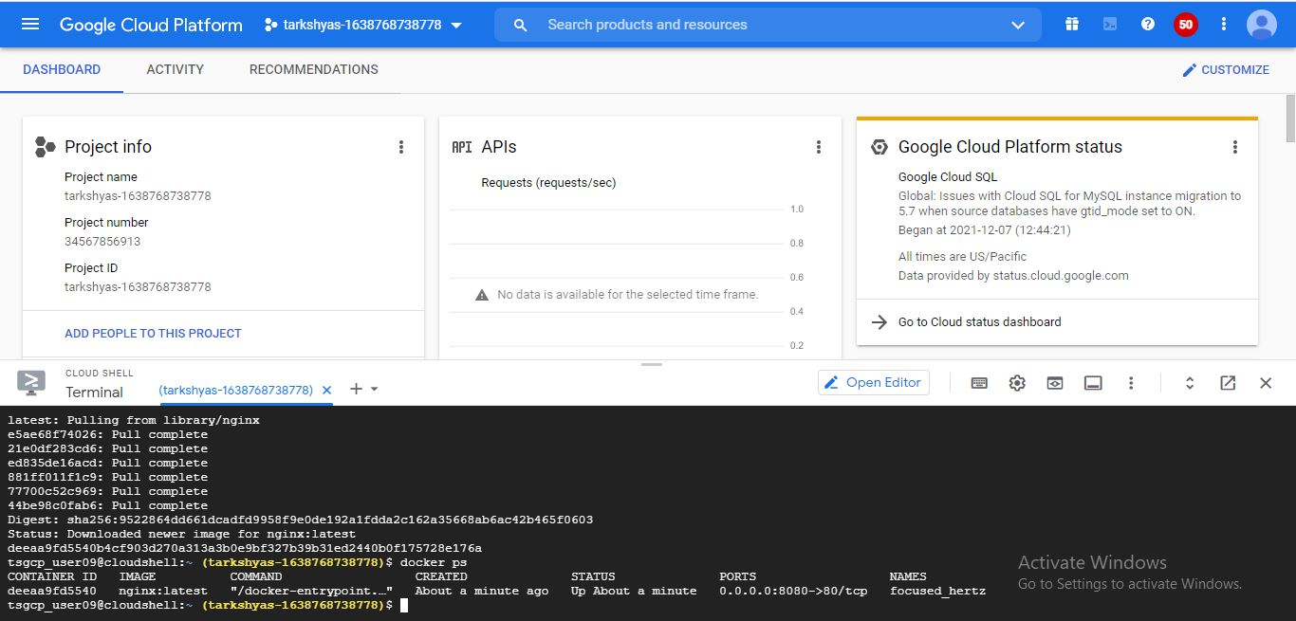

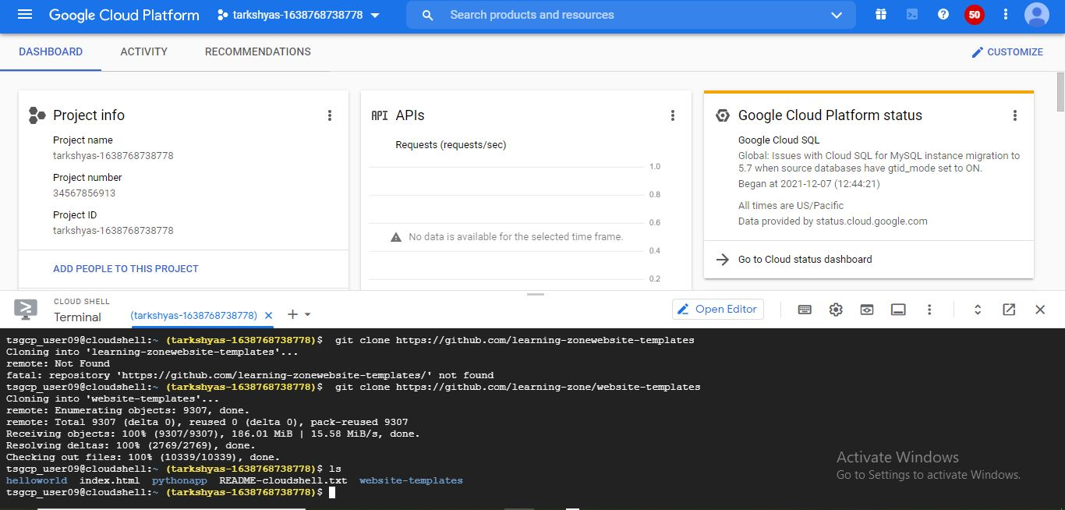

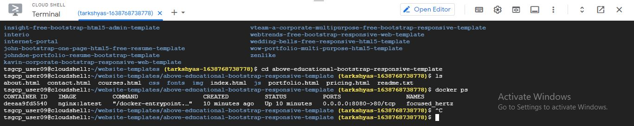

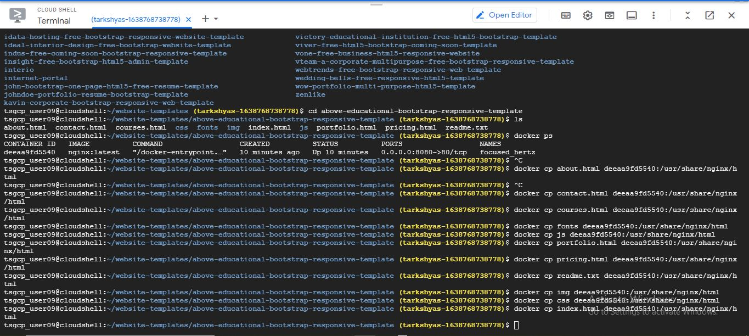

Docker push and run is done as above and authorize the cloud shell to kubernet engine,

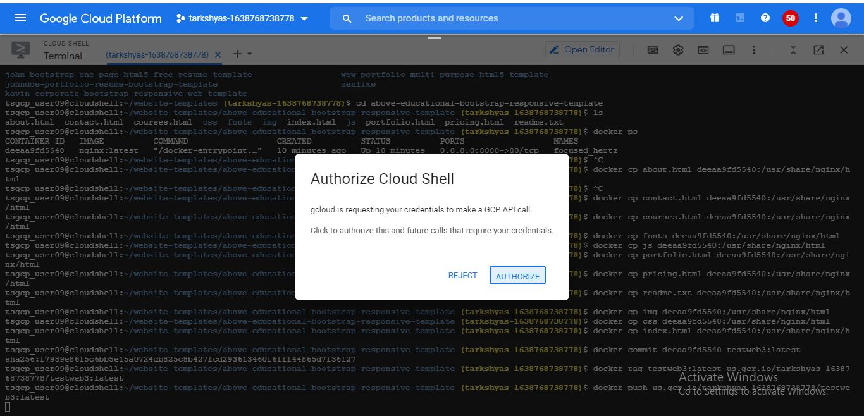

Deployment is created in kubernet engine with default settings,

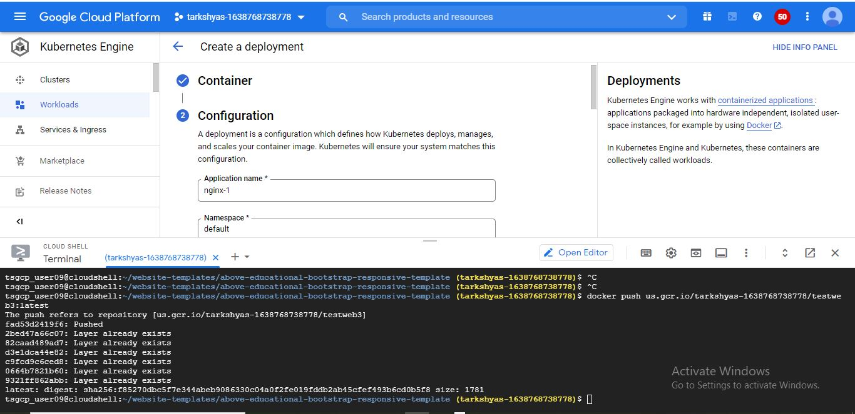

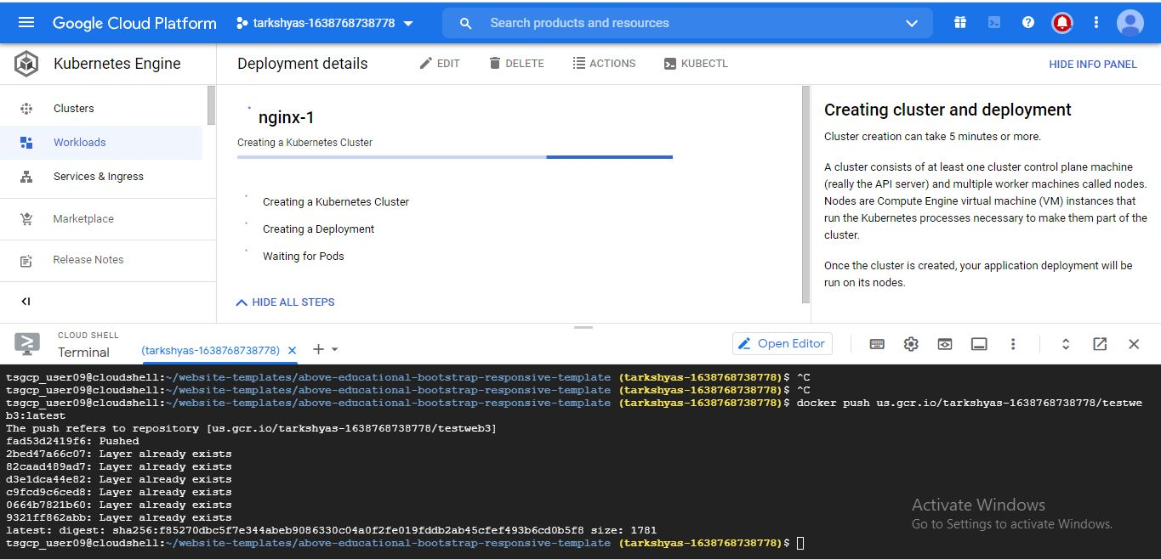

The service is created as shown below,

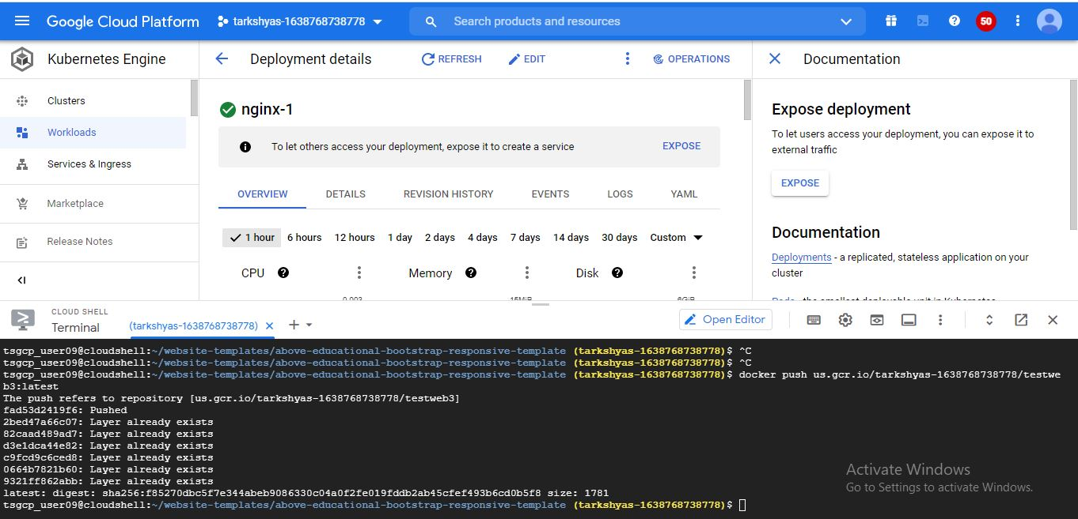

And also access multiple webpage,



11)Terraform is an open source tool that lets provision google cloud resources with declarative configuration files-resources such as VM,containers,storage,and networking.

The different applications were downloaded from the links and follow the steps.

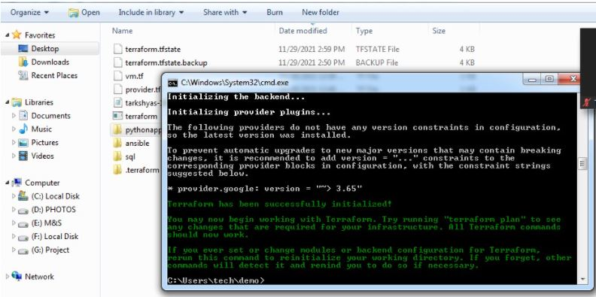

Initialized the gcloud as follows,

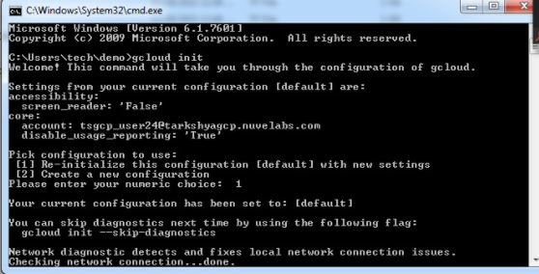

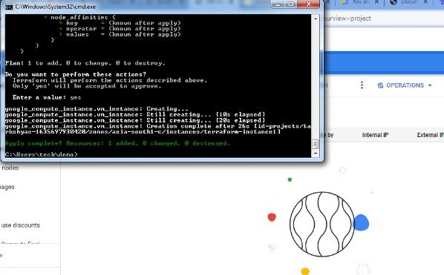

The vm instance were created.

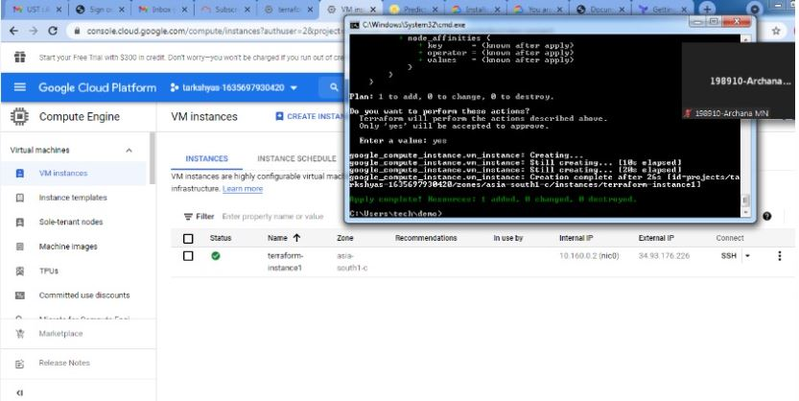

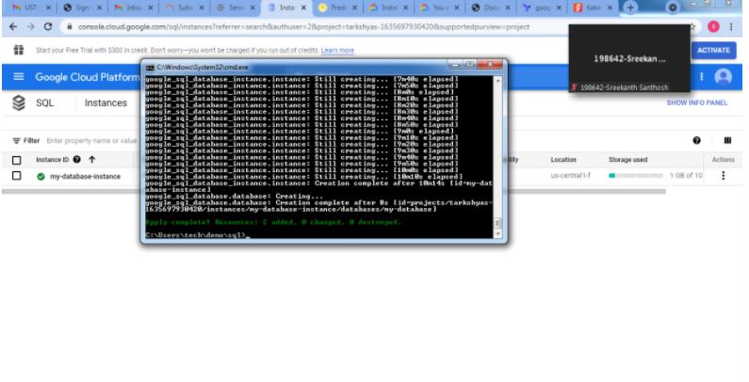

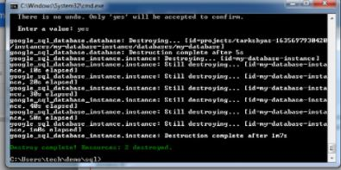

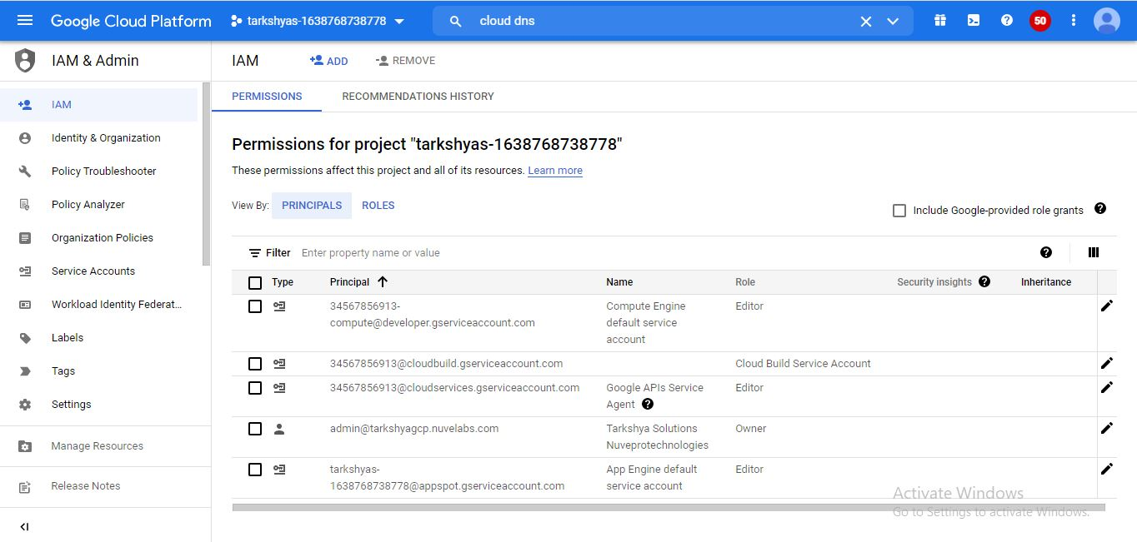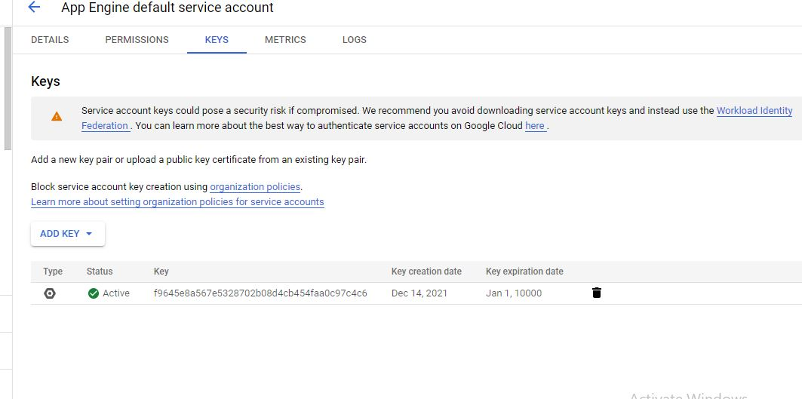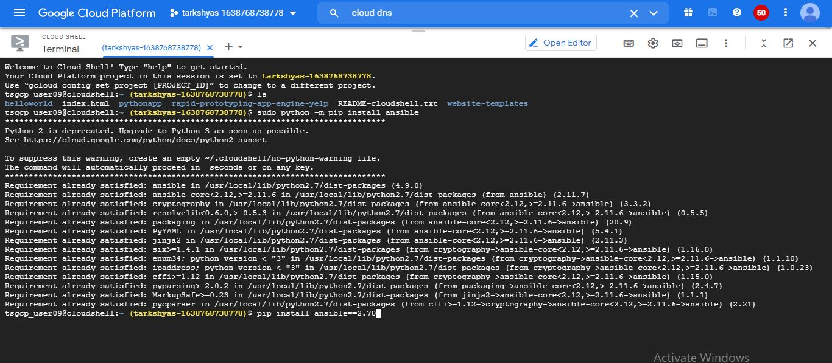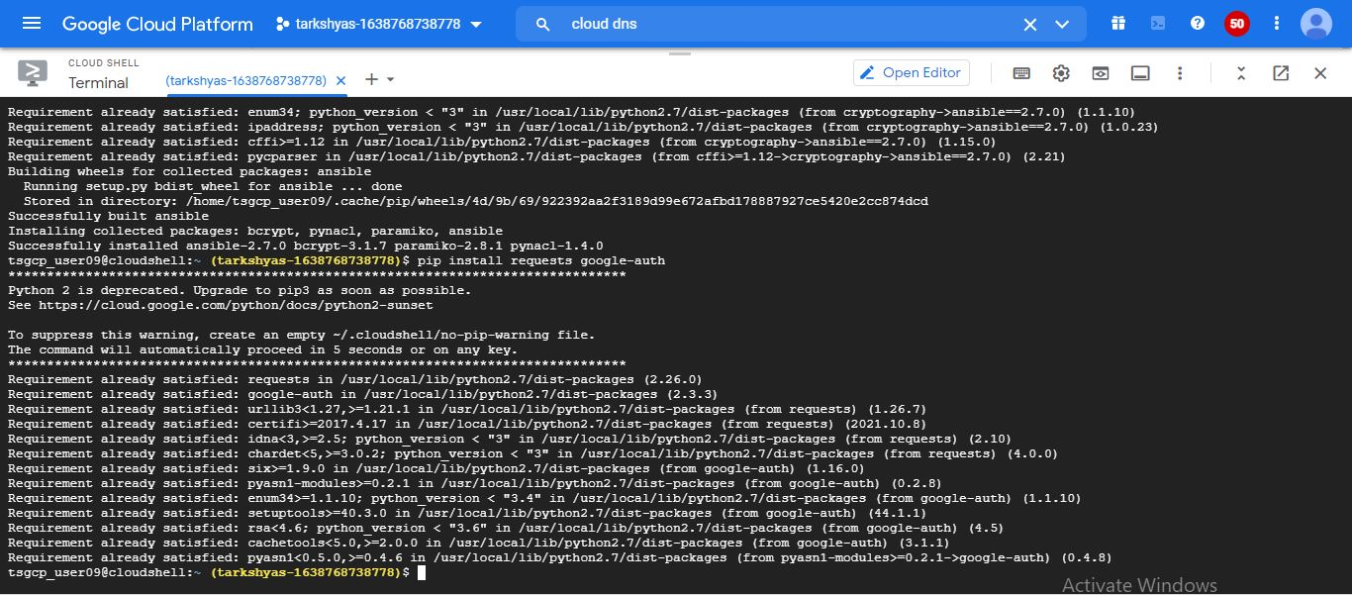



Also the vm instance is created with ansible.

12)Big query

Bigquery is a fully managed enterprise data warehouse that helps to manage and analyze data with built-in features.We can insert data the can use orderby and also group by.

First enable the Big query API,

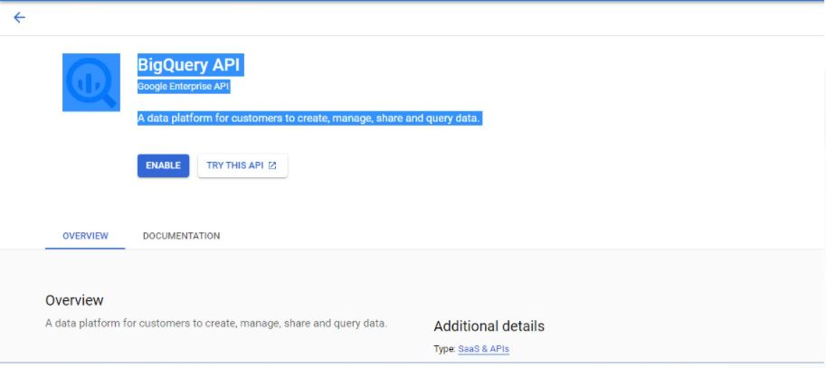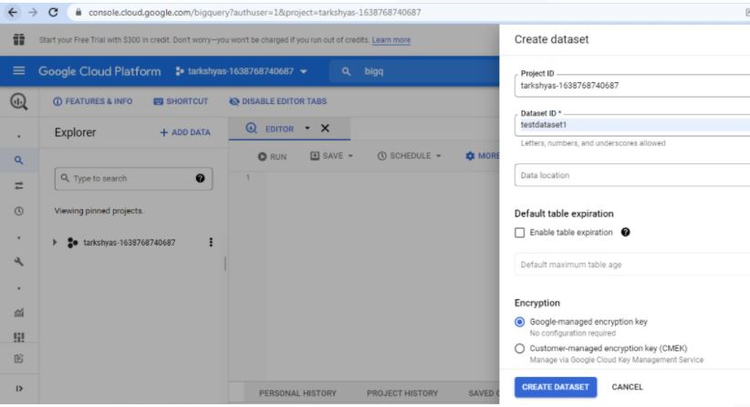

A database is created with project id and dataset id.

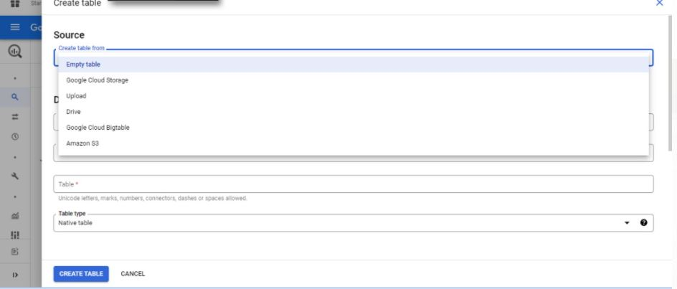

A table is created as above and create a bucket on big query.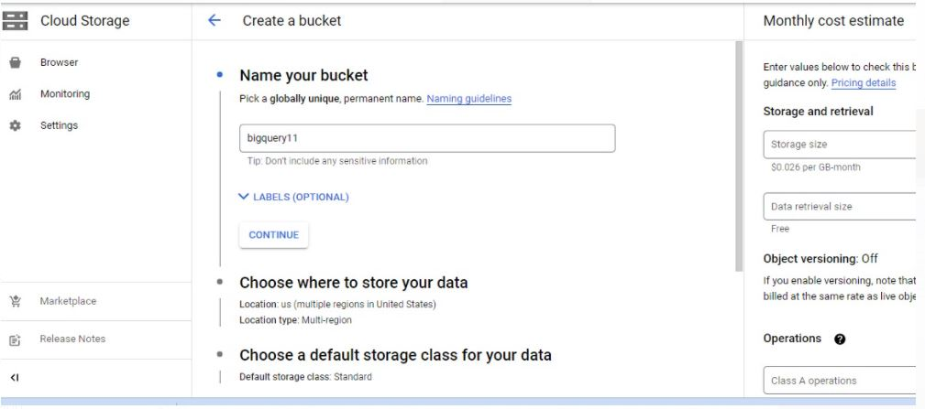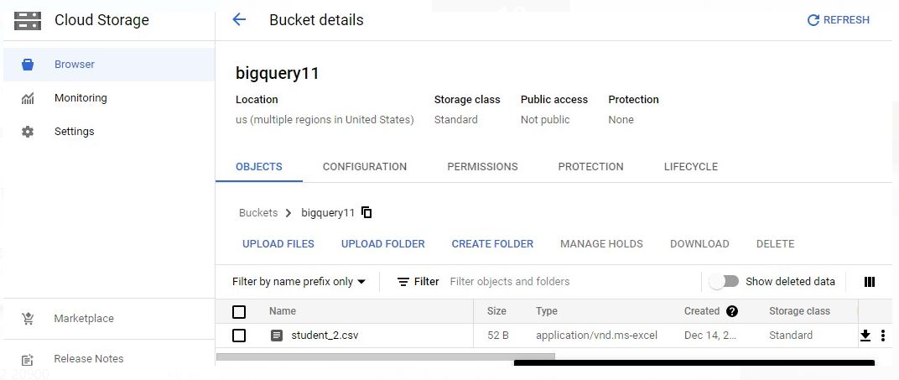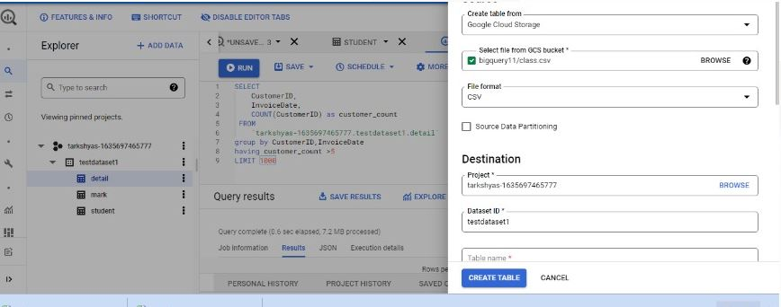

In the table name give the query and run.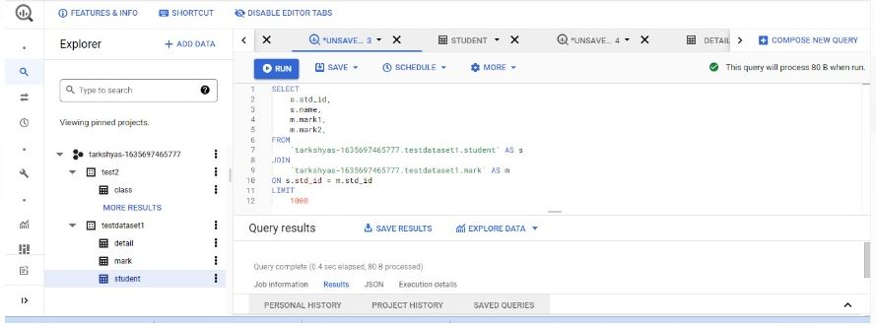

By inserting the table contents a table is created.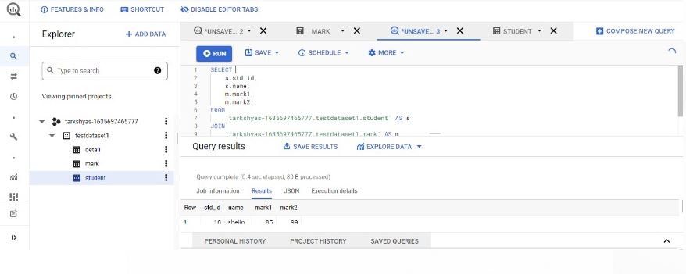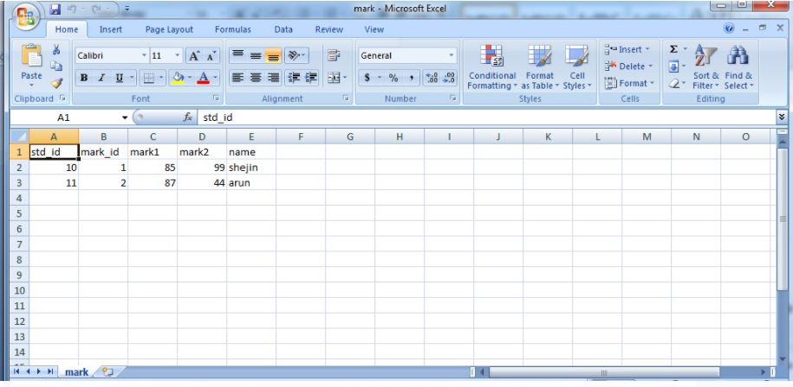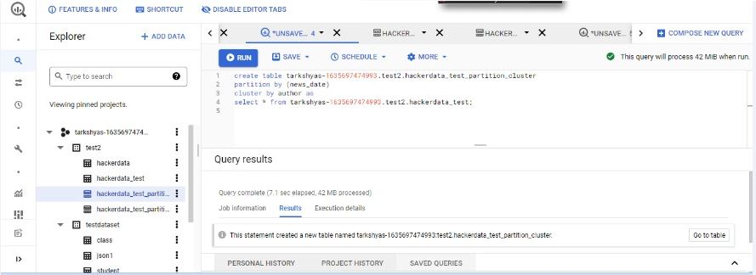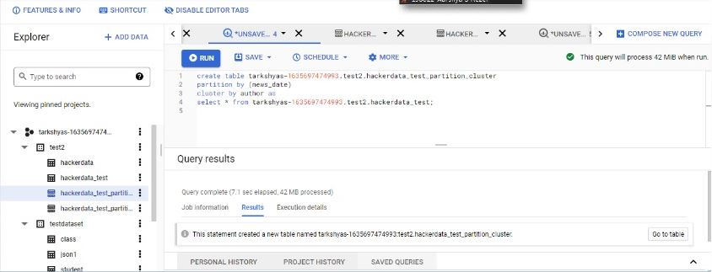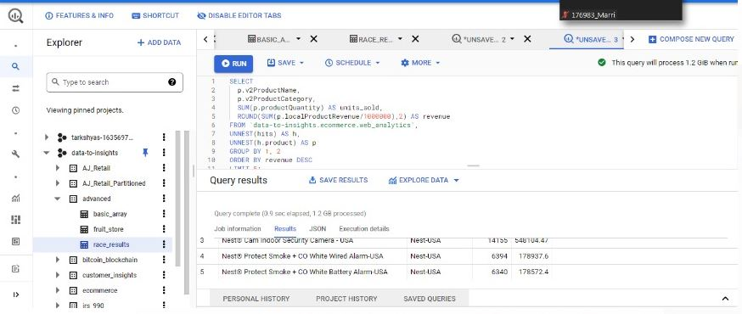

Different functions like order by,query optimization,partitioning,clustering and group by are done as,